Name

Mathematics Stage 5 Core
Index Laws

Book 1 | Extend and apply the index laws to variables  Simplify algebraic products and quotients using index laws | Version: 260517  Feedback:  https://MrDingMaths.com
Contents
Syllabus Content 2
Index Law of Multiplication 3
Index Law of Division 9
Index Law of Power of a Power 16
Index Law of Zero 21
Index Laws with Coefficients 25
Index Laws with More than One Variable 31
Mixed Practice: Basic Index Laws 36
Power of a Product 49
Power of a Quotient 55
Mixed Practice: Power of a Product and Quotient 60

Syllabus Content
MA5-IND-C-01 simplifies algebraic expressions involving positive-integer and zero indices, and establishes the meaning of negative indices for numerical bases
Extend and apply the index laws to variables, using positive-integer indices and the zero index
- Apply the index laws for numerical bases with positive-integer indices to develop the index laws in algebraic form
- Establish that $x^{0}=1$ algebraically using index laws
- Simplify algebraic expressions that involve the zero index
Simplify algebraic products and quotients using index laws
- Simplify algebraic expressions that involve powers, products and quotients of simple algebraic terms containing positive-integer indices

Index Law of Multiplication

- Review
- Recall index notation
Write, showing repeated multiplication
- $a^{5}$ | - $5^{2}$ | - $m^{4}$ | - $x^{5}$
- Recall index law of multiplication for numerical bases
- $2^{3}×2$ | - $2^{3}×2^{2}$ | - $7^{3}×7^{12}$
- $2^{3}×5^{12}$ | - $x+x+x$ | - $x×x×x$

- Identify when to use index law of multiplication
✖  $$5^{3}×7^{2}$$ | ✔  $$5^{3}×5^{2}$$ |  | ✔  $$x^{4}×x^{9}$$ |  | ✔  $$m×m^{3}$$ |  | ✖  $$m+m^{3}$$
Identify whether you can apply the index law of multiplication
- $4^{2}×7^{3}$ |  | - $a^{5}×a^{2}$ |  | - $x^{5}×y^{2}$ |  | - $p×p^{6}$
- $2^{4}×3^{4}$ |  | - $b^{10}×b$ |  | - $b^{10}+b$ |  | - $x^{5}×y^{5}$

- Index Law of Multiplication
$$a^{m}×a^{n}=a^{m+n}$$

- Simplify using index law of multiplication
$$x^{3}×x^{4}$$  $$=x^{7}$$ | $$x^{3}×x^{40}$$  $=x^{43}$ | $$y^{3}×y^{40}$$  $=y^{43}$
Simplify the following expressions
- $x^{2}×x^{5}$ | - $a^{6}×a^{3}$ | - $m×m^{7}$
- $b^{4}×b^{2}×b^{3}$ | - $x^{2}×y^{3}$ | - $2^{5}×2^{3}$
- ${\left(x+3\right)}^{7}×{\left(x+3\right)}^{4}$ | - $y×y$ | - $y+y$

- Key Ideas
- When multiplying powers with the same base, ……………… the powers.
- $x^{m}×x^{n}=$ …………
- The law only applies when the base is the …………… in both terms.

Foundation
- Find the missing numbers.
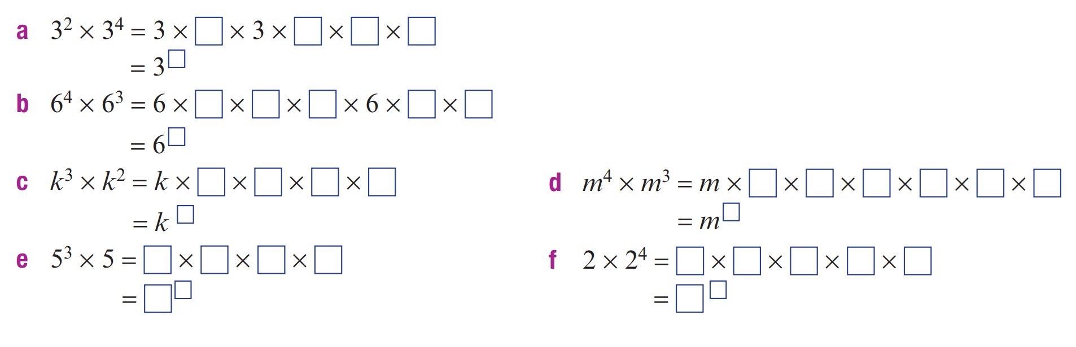  $$3^{6}$$ | $$6^{7}$$
$$k^{5}$$ | $$m^{7}$$
$$5^{4}$$ | $$2^{5}$$

- Explain why you can’t simplify $x^{2}×y^{3}$ using index laws.

The bases are not the same.
- For each, write ✓ if the index law of multiplication applies, or ✗ if it does not.
- $5^{3}×5^{7}$  ✓ | - $m^{5}×m^{2}$  ✓ | - $6^{3}×6$  ✓ | - $4^{5}×4^{2}$  ✓
- $x^{4}×y^{3}$  ✗ | - $b×b^{9}$  ✓ | - $c×d^{2}$  ✗ | - $h^{3}×h$  ✓
- $a^{2}×a^{5}$  ✓ | - $x^{2}×y^{2}$  ✗ | - $n^{5}×n^{3}×n^{2}$  ✓ | - $e^{2}×f^{2}$  ✗
- $2^{3}×3^{4}$  ✗ | - $p^{4}×p^{7}$  ✓ | - $q^{2}×r^{3}$  ✗ | - $t^{4}×t×t^{3}$  ✓

- For each, write each as a single power.
- $x^{2}×x^{3}$  $$x^{5}$$ | - $x^{3}×x^{4}$  $$x^{7}$$ | - $x^{5}×x^{2}$  $$x^{7}$$
- $x^{2}×x^{4}$  $$x^{6}$$ | - $x^{3}×x^{5}$  $$x^{8}$$ | - $x^{5}×x^{3}$  $$x^{8}$$
- $x^{2}×x^{5}$  $$x^{7}$$ | - $x^{4}×x^{3}$  $$x^{7}$$ | - $x^{6}×x^{2}$  $$x^{8}$$
- $x^{2}×x^{6}$  $$x^{8}$$ | - $x^{4}×x^{5}$  $$x^{9}$$ | - $x^{7}×x^{3}$  $$x^{10}$$

- For each, write each as a single power.
- $x×x^{2}$  $$x^{3}$$ | - $y^{5}×y$  $$y^{6}$$ | - $b^{2}×b$  $$b^{3}$$ | - $n^{3}×n×n^{2}$  $$n^{6}$$

Development
- Write each of these using a single power.
$$x^{7}$$ | 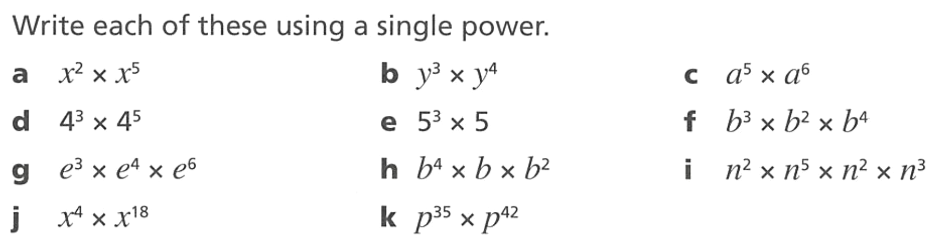  $$y^{7}$$ | $$a^{11}$$
$$4^{8}$$ | $$5^{4}$$ | $$b^{9}$$
$$e^{13}$$ | $$b^{7}$$ | $$n^{12}$$
$$x^{22}$$ | $$p^{77}$$

- Laura is simplifying $e^{4}×e^{3}$.

You multiply the powers, so the answer is $e^{12}$

Explain why she is incorrect and state the correct answer.
When multiplying the same base numbers, we add the powers.
$$e^{7}$$
- Julie is simplifying $w^{4}×w$

The answer is $w^{4}$ since the second $w$ has no power.

Explain why she is incorrect and state the correct answer.
The second power has a power of 1.
$$w^{5}$$
- Simplify, if possible.
- $w^{5}×w^{2}×w^{3}×w$  $$w^{11}$$ | - $h^{4}×h^{4}×h^{4}$  $$h^{12}$$ | - $p^{99}×p$  $$p^{100}$$
- $q^{100}×q^{100}$  $$q^{200}$$ | - $s^{200}×s^{300}$  $$s^{500}$$ | - $m×m^{3}$  $$m^{4}$$
- $h^{2}+h^{2}$  $$2h^{2}$$ | - $m+m^{3}$  Can’t simplify | - $a^{4}×b^{5}$  $$a^{4}b^{5}$$

Mastery
- Write as a single power, if possible.
- $7^{9}×7^{6}$  $$7^{15}$$ | - $y^{9}×y^{6}$  $$y^{15}$$ | - $a^{9}×b^{6}$  Can’t simplify
- ${\left(2x+3\right)}^{9}×{\left(2x+3\right)}^{6}$  $${\left(2x+3\right)}^{15}$$ | - ${\left(\sqrt{7}\right)}^{9}×{\left(\sqrt{7}\right)}^{6}$  $${\left(\sqrt{7}\right)}^{15}$$ | - $9^{7}×6^{7}$  Can’t simplify

- Work out the missing powers.
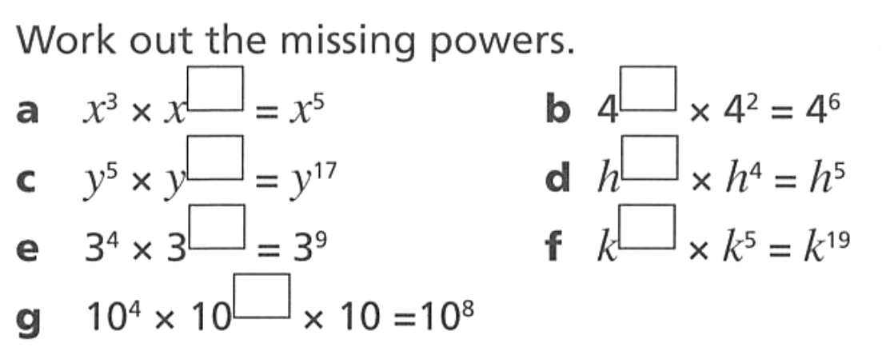  2 | 4 | 12 | 1
5 | 14 | 3

- Write each of these expressions as a single term.
- $2^{x}×2^{3x}$  $$2^{4x}$$ | - $5^{3x-1}×5^{7x}$  $$5^{10x-1}$$ | - $r^{2y+3}×r^{y-2}$  $$r^{3y+1}$$

- Every answer is incorrect, state the error and write the correct answer.
  - $x^{3}×x^{4}=x^{12}$
Multiplied instead of added the exponents. Correct: $x^{7}$
  - $y^{5}×y=y^{5}$
Forgot the implied exponent of 1. Correct: $y^{6}$
  - $a^{2}×a^{2}=2a^{4}$
Added the bases. Correct: $a^{4}$
  - $b^{3}×b^{4}=b^{34}$
Wrote the exponents next to each other. Correct: $b^{7}$
  - $m^{5}×n^{3}=mn^{8}$
Bases different, cannot use index laws. Correct simplification is $m^{5}n^{3}$
  - $p^{2}×p^{3}=2p^{5}$
There is no 2; just keep the base. Correct: $p^{5}$
  - $w^{6}×w^{2}=w^{4}$
Subtracted instead of added. Correct: $w^{8}$
- Find the value of $x$ in these equations.
- $3^{x}×3^{x}=3^{10}$  $$3^{2x}=3^{10}$$  $$2x=10$$  5 | - $5^{x+1}×5^{2x}=5^{13}$  4 | - $a^{x}×a^{4x}×a^{2}=a^{32}$  6
- $7^{x-5}×49=7^{6}$  9 | - $m^{2x}×m^{x-2}=m^{x}×m^{4}$  3

Index Law of Division

- Review
- Simplify fractions by cancelling common factors
$$\frac{5×5×5}{5}$$ | $$\frac{7×7×7×7×7}{7×7}$$
$$\frac{7}{7×7×7}$$ | $$\frac{2×2}{2×2×2}$$
- Recall index law of division for numerical bases
- $5^{7}÷5^{3}$ | - $3^{4}÷3$ | - $\frac{7^{5}}{7^{2}}$ | - $\frac{2^{9}}{2^{3}}$

- Index Law of Division
$$a^{m}÷a^{n}=a^{m-n}$$

- Simplify using index law of division
$$x^{7}÷x^{3}$$  $=x^{4}$ | $$x^{43}÷x^{40}$$  $=x^{3}$ | $$y^{953}÷y^{900}$$  $=y^{53}$
Simplify the following expressions
- $x^{6}÷x^{2}$ | - $a^{7}÷a^{3}$ | - $y^{8}÷y$
- $a^{9}÷a^{2}÷a^{4}$ | - $y^{5}÷y^{5}$ | - $\frac{x^{7}}{x^{2}}$
- $\frac{y^{9}}{y^{4}}$ | - $x^{5}-x^{3}$ | - $x^{3}÷y^{2}$

- Index Law of Division
When the numerator has a higher power, find the difference of the powers, and the base is in the numerator.  $$\frac{x^{11}}{x^{2}}÷\frac{x^{2}}{x^{2}}$$  $$=\frac{x^{9}}{1}=x^{9}$$ | When the denominator has a higher power, find the difference of the powers, and the base is in the denominator.  $$\frac{x^{2}}{x^{11}}÷\frac{x^{2}}{x^{2}}$$  $$=\frac{1}{x^{9}}$$

- Apply Index law of division
$$\frac{x^{5}}{y^{3}}$$  Law doesn’t apply | $$\frac{x^{9}}{x^{2}}=x^{7}$$ |  | $$\frac{x^{2}}{x^{7}}=\frac{1}{x^{7}}$$ |  | $$\frac{x^{20}}{x^{7}}=x^{13}$$ |  | $$\frac{x^{20}}{x^{70}}=\frac{1}{x^{50}}$$
Simplify the following expressions
- $\frac{x^{6}}{x^{2}}$ |  | - $\frac{x^{2}}{x^{6}}$ |  | - $\frac{x^{5}}{x^{11}}$ |  | - $\frac{x^{11}}{x^{5}}$
- $\frac{y^{30}}{y^{26}}$ |  | - $\frac{m^{3}}{m^{10}}$ |  | - $\frac{p^{9}}{p^{2}}$ |  | - $\frac{m^{2}}{m^{15}}$

- Key Ideas
- When dividing powers with the same base, ……………… the powers.
- $x^{m}÷x^{n}=$ …………
- Fractions also represent …………………, so $\frac{x^{m}}{x^{n}}$ $=$
- $\frac{x^{20}}{x^{4}}$ $=$ ……… and $\frac{x^{4}}{x^{20}}$ $=$ ………
- The law only applies when the base is the …………… in both terms

Foundation
- Fill in the boxes.
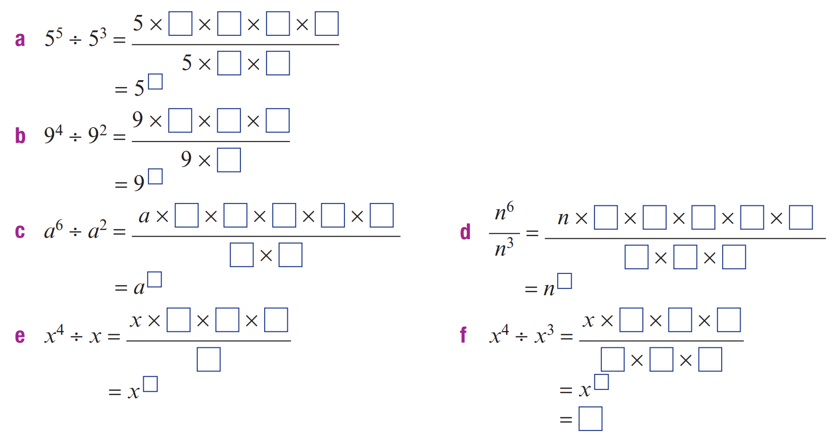  $$5^{2}$$ | $$9^{2}$$
$$a^{4}$$ | $$n^{3}$$

- Write as a single power.
- $x^{5}÷x^{2}$  $$x^{3}$$ | - $x^{8}÷x^{3}$  $$x^{5}$$ | - $m^{12}÷m^{7}$  $$m^{5}$$
- $x^{6}÷x^{2}$  $$x^{4}$$ | - $a^{9}÷a^{4}$  $$a^{5}$$ | - $n^{15}÷n^{6}$  $$n^{9}$$
- $x^{7}÷x^{2}$  $$x^{5}$$ | - $b^{10}÷b^{5}$  $$b^{5}$$ | - $p^{20}÷p^{15}$  $$p^{5}$$

- Write as a single power.
- $\frac{x^{5}}{x^{2}}$  $$x^{3}$$ | - $\frac{c^{10}}{c^{4}}$  $$c^{6}$$ | - $\frac{n^{20}}{n^{5}}$  $$n^{15}$$
- $\frac{a^{7}}{a^{3}}$  $$a^{4}$$ | - $\frac{h^{8}}{h^{3}}$  $$h^{5}$$ | - $\frac{p^{7}}{p}$  $$p^{6}$$
- $\frac{b^{9}}{b^{2}}$  $$b^{7}$$ | - $\frac{m^{15}}{m^{10}}$  $$m^{5}$$ | - $\frac{q^{100}}{q^{50}}$  $$q^{50}$$

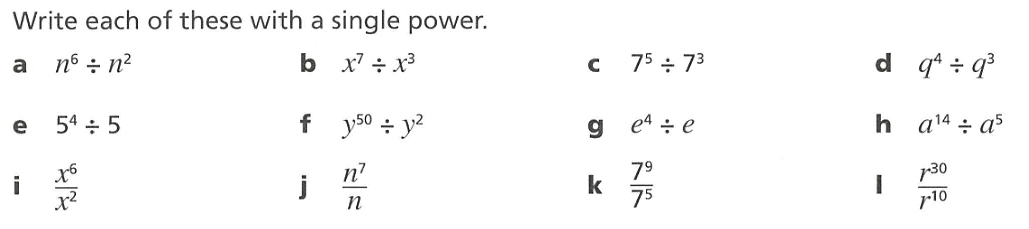
- Write each of these with a single power.
$$n^{4}$$ | $$x^{4}$$ | $$7^{2}$$ | $$q$$
$$5^{3}$$ | $$y^{48}$$ | $$e^{3}$$ | $$a^{9}$$
$$x^{4}$$ | $$n^{6}$$ | $$7^{4}$$ | $$r^{20}$$

- For each question, write $N$ if the numerator has the higher power and $D$ if the denominator has the higher power.
- $\frac{x^{6}}{x^{2}}$  N | - $\frac{p^{2}}{p^{9}}$  D | - $\frac{c^{12}}{c^{3}}$  N | - $\frac{t^{4}}{t^{9}}$  D
- $\frac{m^{3}}{m^{10}}$  D | - $\frac{y^{30}}{y^{26}}$  N | - $\frac{h^{5}}{h^{50}}$  D | - $\frac{w^{11}}{w}$  N
- $\frac{a^{15}}{a^{4}}$  N | - $\frac{b^{8}}{b^{20}}$  D | - $\frac{r^{9}}{r^{4}}$  N | - $\frac{u^{2}}{u^{12}}$  D

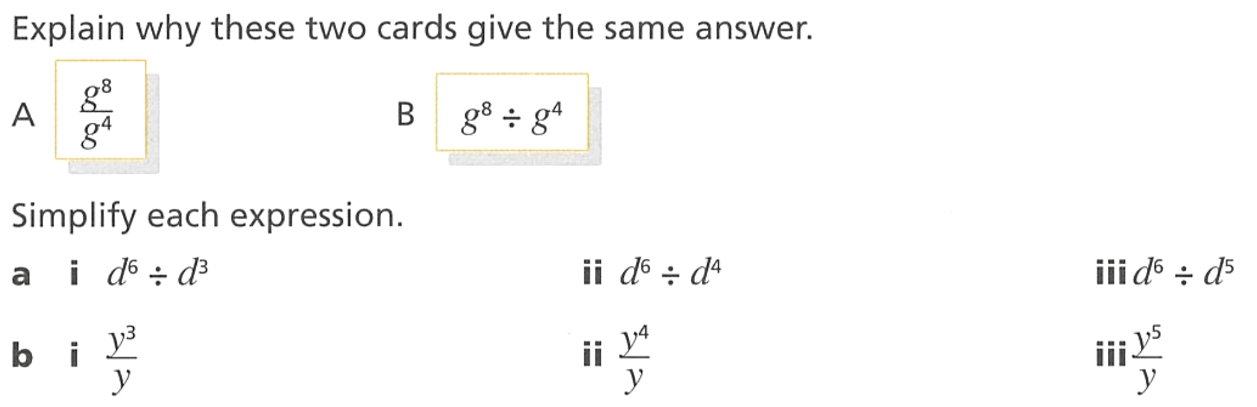
- Explain why these two cards give the same answer.

The fraction bar represents division
Simplify each expression
$$d^{3}$$ | $$d^{2}$$ | $$d$$
$$y^{2}$$ | $$y^{3}$$ | $$y^{4}$$

- Explain why you can’t simplify $\frac{g^{7}}{m^{4}}$

The bases are not the same.
- Write each in the form $\frac{1}{{base}^{n}}$
- $\frac{x^{2}}{x^{5}}$  $$\frac{1}{x^{3}}$$ | - $\frac{c^{4}}{c^{10}}$  $$\frac{1}{c^{6}}$$ | - $\frac{n^{5}}{n^{20}}$  $$\frac{1}{n^{15}}$$
- $\frac{a^{3}}{a^{7}}$  $$\frac{1}{a^{4}}$$ | - $\frac{h^{3}}{h^{8}}$  $$\frac{1}{h^{5}}$$ | - $\frac{p}{p^{7}}$  $$\frac{1}{p^{6}}$$
- $\frac{b^{2}}{b^{9}}$  $$\frac{1}{b^{7}}$$ | - $\frac{m^{10}}{m^{15}}$  $$\frac{1}{m^{5}}$$ | - $\frac{q^{50}}{q^{100}}$  $$\frac{1}{q^{50}}$$

Development
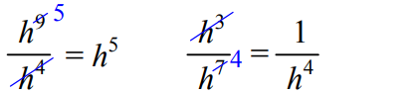
- Look at the example and then answer the questions.

Simplify these.
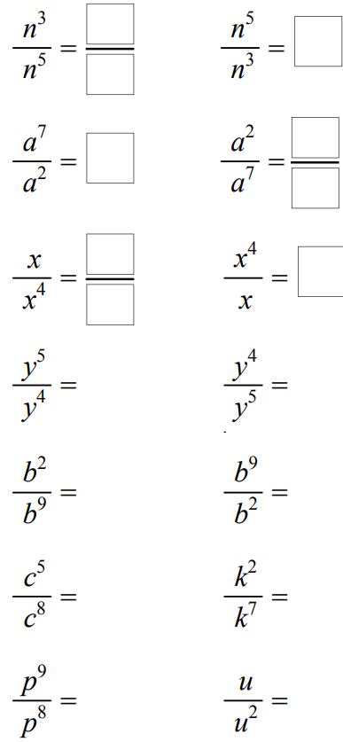  $$\frac{1}{n^{2}}$$ | $$n^{2}$$ | $$a^{5}$$ | $$\frac{1}{a^{5}}$$
$$\frac{1}{x^{3}}$$ | $$x^{3}$$ | $$y$$ | $$\frac{1}{y}$$
$$\frac{1}{b^{7}}$$ | $$b^{7}$$ | $$\frac{1}{c^{3}}$$ | $$\frac{1}{k^{5}}$$

- Simplify.
$$\frac{a^{8}}{a^{3}}$$  $$a^{5}$$ | $$\frac{b^{4}}{b^{11}}$$  $$\frac{1}{b^{7}}$$ | $$c^{15}÷c^{5}$$  $$c^{10}$$ | $$\frac{m^{7}}{m^{2}}$$  $$m^{5}$$
$$\frac{n^{3}}{n^{12}}$$  $$\frac{1}{n^{9}}$$ | $$\frac{q^{6}}{q^{9}}$$  $$\frac{1}{q^{3}}$$ | $$s^{100}÷s^{99}$$  $$s$$ | $$\frac{t}{t^{5}}$$  $$\frac{1}{t^{4}}$$

- Simplify each pair.
$$\frac{x^{7}}{x^{2}} and \frac{x^{2}}{x^{7}}$$  $$x^{5},\frac{1}{x^{5}}$$ | $$\frac{a^{5}}{a^{3}} and \frac{a^{3}}{a^{5}}$$  $$a^{2},\frac{1}{a^{2}}$$
$$\frac{m^{4}}{m^{10}} and \frac{m^{10}}{m^{4}}$$  $$\frac{1}{m^{6}}, m^{6}$$ | $$\frac{n^{12}}{n^{7}} and \frac{n^{7}}{n^{12}}$$  $$n^{5},\frac{1}{n^{5}}$$
$$\frac{p^{15}}{p^{20}} and \frac{p^{20}}{p^{15}}$$  $$\frac{1}{p^{5}}, p^{5}$$ | $$\frac{q}{q^{9}} and \frac{q^{9}}{q}$$  $$\frac{1}{q^{8}}, q^{8}$$
- Read the example carefully and answer the questions.
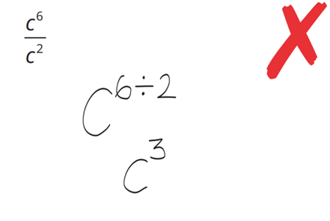 | This student divided her exponents to get her answer. What operation should they have used to get the correct answer?  subtract  Simplify:  $$\frac{b^{6}}{b^{3}}$$  $$b^{3}$$


- Ally says:
$$8^{17}÷8^{15}=1^{2}$$

Explain why she is incorrect and state the correct answer.

The base number does not change.
$$8^{2}$$

- Every answer is incorrect, state the error and write the correct answer.
  - $\frac{a^{7}}{a^{3}}$ $=a^{\frac{7}{3}}$
Divided the powers. Correct: $a^{4}$
  - $b^{8}÷b^{5}=1^{3}$
Divided the base too. Correct: $b^{3}$
  - $\frac{c^{9}}{c^{4}}$ $=c^{13}$
Added instead of subtracted. Correct: $c^{5}$
  - $\frac{d^{3}}{d^{10}}$ $=d^{7}$
Numerator is smaller, answer should have base on the bottom. Correct: $\frac{1}{d^{7}}$
  - $f^{10}÷f=f^{10}$
Forgot the implied power of 1. Correct: $f^{9}$

Mastery
- Work out the missing powers.
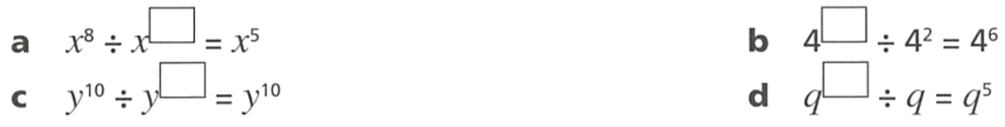  3 | 8
0 | 6

- Simplify these expressions.
- $7^{5a}÷7^{2a}$  $$7^{3a}$$ | - $y^{5x+3}÷y^{2x}$  $$y^{3x+3}$$ | - $y^{2m+3}÷y^{m+5}$  $$y^{m-2}$$

- Evaluate without a calculator.
- $7^{7}÷7^{5}$  49 | - ${10}^{6}÷{10}^{5}$  10 | - ${13}^{11}÷{13}^{9}$  169
- $2^{20}÷2^{17}$  8 | - $7×{31}^{16}÷{31}^{15}$  217 | - $3×{50}^{200}÷{50}^{198}$  7500

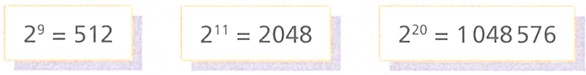
- Consider this information:

Use this information to work out the answers to these calculations.
- $1 048 576÷2048$  512 | - $1 048 576÷512$  2048

Index Law of Power of a Power

- Review
- Simplify expressions using the index law of multiplication
- $x^{3}×x^{3}$ | - $x^{3}×x^{3}×x^{3}$
- $x^{3}×x^{3}×x^{3}×x^{3}$ | - ${\left(y^{5}\right)}^{2}$

- Write out power of a power in expanded form
- ${\left(x^{3}\right)}^{4}$ | - ${\left(x^{5}\right)}^{2}$

- Index Law of Power of a Power
$${\left(a^{m}\right)}^{n}=a^{m×n}$$

- Simplify using index law of power of a power
$${\left(x^{3}\right)}^{4}$$  $=x^{12}$ | $${\left(x^{3}\right)}^{5}$$  $=x^{15}$ | $${\left(a^{20}\right)}^{6}$$  $=a^{120}$
Simplify the following expressions
- ${\left(x^{2}\right)}^{3}$ | - ${\left(y^{3}\right)}^{5}$ | - ${\left(a^{4}\right)}^{2}$
- ${\left(b^{2}\right)}^{4}$ | - ${\left(n^{10}\right)}^{2}$ | - ${\left(x^{2}\right)}^{3}×x^{4}$

- Identify whether to add to multiply the powers
$$x^{3}×x^{4}$$  Add | $${\left(x^{3}\right)}^{4}$$  Multiply |  | $${\left(a^{5}\right)}^{2}$$  Multiply |  | $${\left(m^{10}\right)}^{3}$$  Multiply |  | $$x^{3}×x^{4}×x^{5}$$  Add
Identify whether to add the powers or multiply the powers.
- $(y^{4})^{3}$ |  | - $x^{2}×x^{5}$ |  | - $(a^{7})^{2}$ |  | - ${\left(c^{5}\right)}^{3}$
- $b^{4}×b^{9}$ |  | - $m^{6}×m×m^{2}$ |  | - $x^{2}x^{5}$ |  | - ${\left(m^{2}\right)}^{3}$

- Key Ideas
- When two terms are multiplied, e.g. $x^{3}×x^{4}$, we …………… the powers.
- When a power is raised to another power, e.g. ${\left(x^{3}\right)}^{4}$, we …………… the powers.

Foundation
- For each, write $+$ if you add the powers, and $×$ if you multiply the powers.
- $(x^{3})^{4}$  $$×$$ | - $b^{4}×b^{9}$  $$+$$ | - $(n^{7})^{3}$  $$×$$ | - $r^{4}×r^{4}$  $$+$$
- $x^{3}×x^{4}$  $$+$$ | - $(c^{3})^{5}$  $$×$$ | - $p^{8}×p^{2}$  $$+$$ | - $(s^{2})^{9}$  $$×$$
- $(a^{5})^{2}$  $$×$$ | - $m^{6}×m×m^{2}$  $$+$$ | - $(q^{10})^{4}$  $$×$$ | - $(t^{6})^{6}$  $$×$$

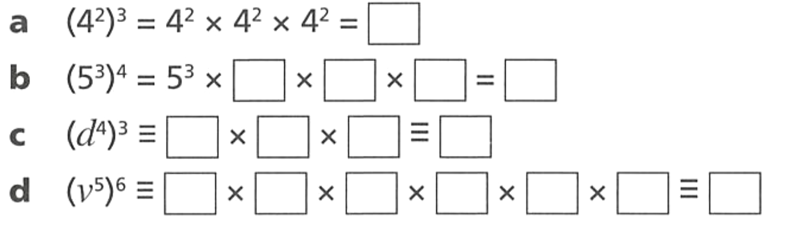
- Complete the following.
$$4^{6}$$
$$5^{12}$$
$$d^{12}$$
$$v^{30}$$
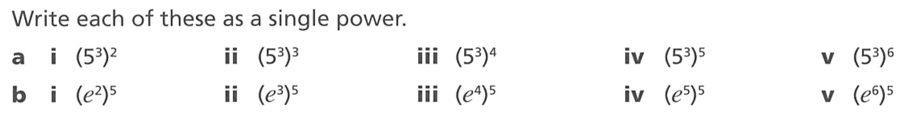
- Write each of these as a single power.
$$5^{6}$$ | $$5^{9}$$ | $$5^{12}$$ | $$5^{15}$$ | $$5^{18}$$
$$e^{10}$$ | $$e^{15}$$ | $$e^{20}$$ | $$e^{25}$$ | $$e^{30}$$

- Simplify
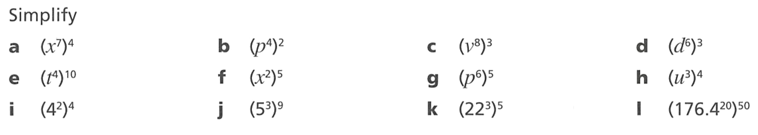  $$x^{28}$$ | $$p^{8}$$ | $$v^{24}$$ | $$d^{18}$$
$$t^{40}$$ | $$x^{10}$$ | $$p^{30}$$ | $$u^{12}$$
$$4^{8}$$ | $$5^{27}$$ | $${22}^{15}$$ | $${\left(176.4\right)}^{1000}$$

- Simplify.
- $(x^{3})^{4}$  $$x^{12}$$ | - $b^{4}×b^{9}$  $$b^{13}$$ | - $(n^{7})^{3}$  $$n^{21}$$ | - $r^{4}×r^{4}$  $$r^{8}$$
- $x^{3}×x^{4}$  $$x^{7}$$ | - $(c^{3})^{5}$  $$c^{15}$$ | - $p^{8}×p^{2}$  $$p^{10}$$ | - $(s^{2})^{9}$  $$s^{18}$$
- $(a^{5})^{2}$  $$a^{10}$$ | - $m^{6}×m×m^{2}$  $$m^{9}$$ | - $(q^{10})^{4}$  $$q^{40}$$ | - $(t^{6})^{6}$  $$t^{36}$$

Development
- Simplify
- ${\left(6^{2}\right)}^{5}=$  $$6^{10}$$ | - ${\left(3^{2}\right)}^{\frac{1}{2}}=$  $$3$$
- ${\left(6^{3}\right)}^{5}=$  $$6^{15}$$ | - ${\left(3^{\frac{1}{2}}\right)}^{2}=$  $$3$$
- ${\left(6^{4}\right)}^{5}=$  $$6^{20}$$ | - ${\left(3^{\frac{1}{2}}\right)}^{\frac{1}{2}}=$  $$3^{\frac{1}{4}}$$
- ${\left(2^{4}\right)}^{5}=$  $$2^{20}$$ | - ${\left(x^{2}\right)}^{2}=$  $$x^{4}$$
- ${\left(2^{5}\right)}^{4}=$  $$2^{20}$$ | - ${\left(x^{2}\right)}^{7}=$  $$x^{14}$$
- ${\left(2^{5}\right)}^{0}=$  $$1$$ | - ${\left(2^{7}\right)}^{x}=$  $$2^{7x}$$
- ${\left(2^{5}\right)}^{-1}=$  $$2^{-5}$$ | - ${\left(7^{x}\right)}^{2}=$  $$7^{2x}$$
- ${\left(2^{-5}\right)}^{-1}=$  $$2^{5}$$ | - ${\left(x^{2}\right)}^{5}=$  $$x^{10}$$
- ${\left(3^{-5}\right)}^{-1}=$  $$3^{5}$$ | - ${\left(x^{2}\right)}^{a}=$  $$x^{2a}$$

- Simplify
- ${\left(p^{\frac{1}{9}}\right)}^{\frac{2}{5}}$  $$p^{\frac{2}{45}}$$ | - ${\left(h^{\frac{3}{4}}\right)}^{\frac{9}{10}}$  $$h^{\frac{27}{40}}$$

- Simplify
- $(x^{2})^{3}×x^{4}$  $$x^{10}$$ | - $(y^{3})^{2}×y^{5}$  $$y^{11}$$ | - $(a^{4})^{2}×a$  $$a^{9}$$
- $b×(b^{2})^{4}$  $$b^{9}$$ | - $(m^{3})^{3}×m^{3}$  $$m^{12}$$ | - $(n^{5})^{2}×n^{2}×n$  $$n^{13}$$
- $(p^{2})^{4}×(p^{3})^{2}$  $$p^{14}$$ | - $(q^{3})^{2}×(q^{2})^{3}$  $$q^{12}$$

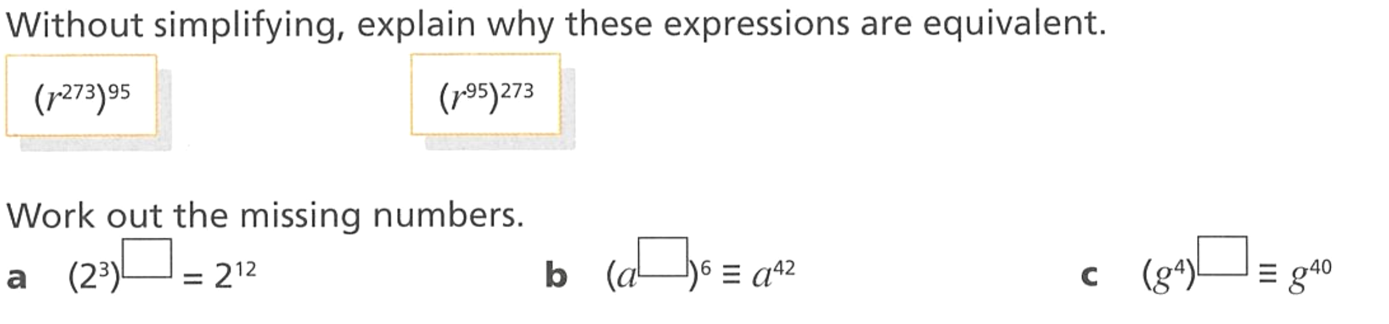
- Without simplifying, explain why these expressions are equivalent.

You can multiply in any order and the product will be the same.

Mastery
- Work out the missing numbers.
4 | 7 | 10

- Work out the missing numbers.
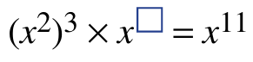  5 | 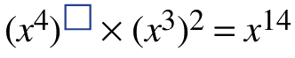  2

- Every answer is incorrect, state the error and write the correct answer.
  - $(x^{3})^{4}=x^{7}$
Added instead of multiplied. Correct: $x^{12}$
  - $(a^{5})^{2}=a^{25}$
Squared instead of multiplied by 2. Correct: $a^{10}$
  - $(b^{2})^{6}=2b^{12}$
There is no 2 in front. Correct: $b^{12}$
  - $(m^{10})^{3}=m^{13}$
Added instead of multiplied. Correct: $m^{30}$

Index Law of Zero

- Review
- Recall index law of division
- $x^{5}÷x^{2}$ | - $n^{6}÷n^{5}$ | - $\frac{y^{7}}{y^{2}}$ | - $\frac{y^{7}}{y^{7}}$

- Divide a number by itself
- $7÷7$ | - $\frac{7}{7}$ | - $x^{3}÷x^{3}$ | - $\frac{y^{7}}{y^{7}}$

- Index Law of Zero
$$x^{0}=1$$

- Simplify using index law of zero
An important question to ask simplifying is ‘what does the zero apply to?’
$$=5x^{0} \\ =5×1 \\ =5$$ | $$={(5x)}^{0} \\ =1$$ |  | $$={(3ab)}^{0} \\ =1$$ |  | $$={x(y^{2})}^{0} \\ =x×1 \\ =x$$ |  | $$={3+a}^{0} \\ =3+1 \\ =3$$
Simplify the following expressions
- $2x^{0}$ |  | - $(2x)^{0}$ |  | - $(4ab)^{0}$ |  | - $4ab^{0}$
- $6-p^{0}$ |  | - $7x^{0}$ |  | - $2x(3yz)^{0}$ |  | - $x+3a^{0}$

- Key Ideas
- Any base raised to the power zero equals ……………
- In the expression $5x^{0}$, the power of zero applies only to ……
In the expression ${\left(5x\right)}^{0},$ the power of zero apples to …………

Foundation
- Simplify these expressions using the power of zero.
- $3^{0}$  1 | - ${25}^{0}$  1 | - $(-5)^{0}$  1
- $7^{0}$  1 | - ${100}^{0}$  1 | - ${\left(\frac{1}{2}\right)}^{0}$  1
- ${10}^{0}$  1 | - $(-2)^{0}$  1 | - ${0.7}^{0}$  1

  - Explain why $\frac{3^{2}}{3^{2}}$ $=1$
Anything divided by itself is 1
  - Using your answer to part a, explain why $3^{0}=1$

$$3^{2}÷3^{2}=3^{0}=1$$
- Simplify these expressions using the power of zero.
- $2x^{0}$  2 | - $10m^{0}$  10 | - $4+b^{0}$  5
- $5y^{0}$  5 | - $-3p^{0}$  $$-3$$ | - $9-c^{0}$  8
- $7a^{0}$  7 | - $-6q^{0}$  $$-6$$ | - $3n^{0}+1$  4

- Simplify these expressions using the power of zero.
- $(2x)^{0}$  1 | - $(10m)^{0}$  1 | - $(4b)^{0}$  1
- $(5y)^{0}$  1 | - $(-3p)^{0}$  1 | - $(9c)^{0}$  1
- $(7a)^{0}$  1 | - $(3n)^{0}+1$  2 | - $(5h)^{0}-2$  $$-1$$

- Simplify these expressions using the power of zero.
- $(xyz)^{0}$  $$1$$ | - $(5mn)^{0}$  $$1$$ | - $a(bc)^{0}$  $$a$$ | - $3(xy)^{0}$  $$3$$
- $7m(np)^{0}$  $$7m$$ | - $-4(rs)^{0}$  $$-4$$ | - $b(bc)^{0}$  $$b$$ | - $-{\left(2b\right)}^{0}$  $$-1$$

Development
- Simplify these expressions using the power of zero.
- $2^{0}=$  1 | - $6^{0}=$  1
- $3^{0}=$  1 | - ${\left(-6\right)}^{0}=$  1
- $4^{0}=$  1 | - ${-(6)}^{0}=$  $$-1$$
- $5^{0}=$  1 | - ${\left(\frac{1}{6}\right)}^{0}=$  1
- $0^{5}=$  0 | - ${\left(0.6\right)}^{0}=$  1
- $0^{4}=$  0 | - ${\left(6p\right)}^{0}=$  1
- $0^{0}=$  undefined | - ${6p}^{0}=$  6

- Simplify these pairs of expressions using the power of zero.
- $4x^{0} and {\left(4x\right)}^{0}$  $$4, 1$$ | - $6y^{0} and (6y)^{0}$  $$6, 1$$
- $-2a^{0} and {\left(-2a\right)}^{0}$  $$-2, 1$$ | - $5m^{0}+3 and (5m)^{0}+3$  $$8, 4$$
- $2x^{0}+2x^{0} and 2x^{0}+(2x)^{0}$  $$4, 3$$ | - $-7a^{0} and {\left(-7a\right)}^{0}$  $$-7, 1$$

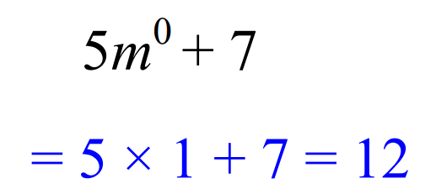
- Evaluate these. Example:

- $2v^{0}$  $$=2×1=$$  2 | - $8h^{0}$  8 | - $h^{0}+7$  8 | - $7h^{0}-4$  3
- $x^{0}$  1 | - $2x^{0}$  2 | - $2x^{0}+2$  4 | - $x^{0}+2x^{0}$  3
- $n^{0}$  1 | - $4^{0}$  1 | - $4n^{0}$  4 | - ${\left(4n\right)}^{0}$  1
- $4n^{0}+4$  8 | - ${\left(n^{0}+4\right)}^{2}$  25 | - $4n^{0}+{\left(4n\right)}^{0}$  5 | - $4^{0}n$  $$n$$

Mastery
- Every answer is incorrect, state the error and write the correct answer.
  - $5x^{0}=0$
The 0 only applies to $x$, so $x^{0}=1$ and the 5 stays. Correct: $5$
  - $(7a)^{0}=7$
The brackets mean the 0 applies to everything inside. Correct: $1$
  - $3a^{0}=1$
The 0 applies only to $a$, so $a^{0}=1$, then $3×1$. Correct: $3$
  - $(2bc)^{0}=2$
The brackets mean the 0 applies to everything inside. Correct: $1$
  - $4+m^{0}=4$
$m^{0}=1$, not 0. Correct: $5$
  - $-2y^{0}=2$
$y^{0}=1$, then $-2×1=-2$. Correct: $-2$

Index Laws with Coefficients

- Review
- Recall index laws
- $x^{3}×x^{5}$ | - $a^{2}×a^{4}$ | - $\frac{x^{8}}{x^{3}}$ | - $\frac{a^{6}}{a^{2}}$
- $y×y^{6}$ | - $\frac{m^{4}}{m^{7}}$ | - ${\left(x^{5}\right)}^{3}$ | - ${\left(x^{2}\right)}^{5}$

- Simplify algebraic expressions
- $3x×5y$ | - $4x×5y$ | - $12x÷6y$
- $16x÷4$ | - $\frac{16x}{8}$ | - $\frac{16}{8x}$

- Identify coefficients and variables
In algebra, variables are letters and coefficients are the numbers multiplied by them.
We work on each separately.
$$4x^{3}×3x^{5}$$  Coefficients: $4×3$  Variables: $x^{3}×x^{5}$ |  | $$2y^{4}×5y^{2}$$  Coefficients: $2×5$  Variables: $y^{4}×y^{2}$ |  | $$\frac{12a^{7}}{4a^{3}}$$  Coefficients: $\frac{12}{4}$  Variables: $\frac{a^{7}}{a^{3}}$
Identify the coefficients and the variables:
$$6x^{2}×2x^{5}$$  Coefficients:  Variables: | $$\frac{10y^{6}}{5y^{2}}$$  Coefficients:  Variables: |  | $$3a^{4}×4a$$  Coefficients:  Variables: |  | $$\frac{8m^{9}}{2m^{3}}$$  Coefficients:  Variables:

- Example Apply index laws to simplify algebraic expressions
$4x^{3}×3x^{5}$  $$=12x^{8}$$ | $2x^{4}×5x^{3}$  $$=10x^{7}$$

- Guided Practice
- $3x^{2}×4x^{5}$  $$12x^{7}$$ | - $2x^{3}×4x^{4}$  $$8x^{7}$$
- $-5x^{2}×3x^{3}$  $$-15x^{5}$$ | - $3x^{4}×2x^{3}×5x^{10}$  $$30x^{17}$$

- Example Apply index laws to simplify algebraic expressions with coefficients
$$\frac{8x^{5}}{6x^{3}}$$  $$=\frac{4x^{2}}{3}$$ | $$\frac{8x^{3}}{6x^{5}}$$  $$=\frac{4}{3x^{2}}$$ | $$\frac{12x^{8}}{4x^{3}}$$  $$=3x^{5}$$

- Guided Practice
- $\frac{{8b}^{5}}{12b^{3}}$  $$\frac{2b^{2}}{3}$$ | - $\frac{{3m}^{2}}{12m^{7}}$  $$\frac{1}{4m^{5}}$$
- $-9m^{6}÷3m^{2}$  $$-3m^{4}$$ | - $2x^{3}×6x^{4}÷4x^{2}$  $$3x^{5}$$

- Key Ideas
- When multiplying terms like $4x³ × 3x⁵,$ multiply the ……………… and ……… the indices
- When dividing terms like $12x⁸ ÷ 4x³$, divide the …………… and ……………… the indices
- The coefficients and the variables are handled …………………

Development
- Simplify each of these expressions.
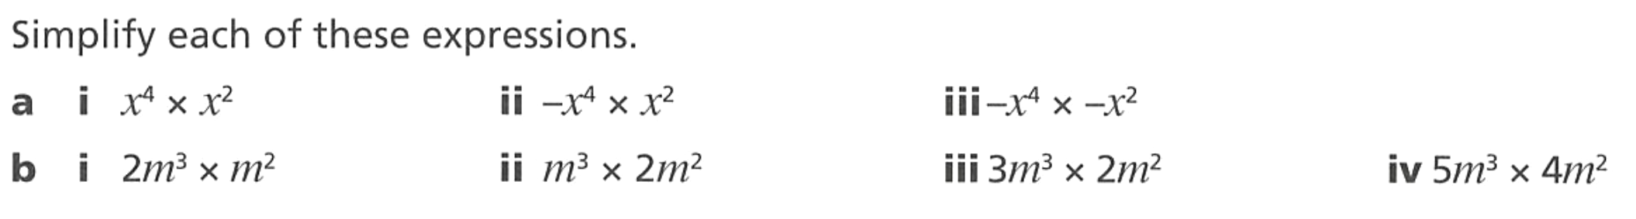  $$x^{6}$$ | $$-x^{6}$$ | $$x^{6}$$
$$2m^{5}$$ | $$2m^{5}$$ | $$6m^{5}$$ | $$20m^{5}$$

- Simplify.
- $5x^{2}×2x^{4}$  $$10x^{6}$$ | - $2b^{6}×5b^{2}$  $$10b^{8}$$ | - $5n^{4}×4n^{4}$  $$20n^{8}$$
- $3a^{4}×4a$  $$12a^{5}$$ | - $4c^{3}×3c^{7}$  $$12c^{10}$$ | - $2p^{5}×7p^{5}$  $$14p^{10}$$
- $6y^{3}×2y^{5}$  $$12y^{8}$$ | - $8h^{2}×2h^{3}$  $$16h^{5}$$ | - $6q^{10}×2q^{2}$  $$12q^{12}$$
- $7m×3m^{4}$  $$21m^{5}$$ | - $9k×2k^{9}$  $$18k^{10}$$ | - $3r^{8}×5r$  $$15r^{9}$$

- Simplify.
- $-3x^{2}×4x^{3}$  $$-12x^{5}$$ | - $-6y^{2}×-3y^{5}$  $$18y^{7}$$ | - $7p^{3}×-p^{5}$  $$-7p^{8}$$
- $5a^{4}×-2a^{3}$  $$-10a^{7}$$ | - $-4m×2m^{6}$  $$-8m^{7}$$ | - $-2q^{4}×-5q^{4}$  $$10q^{8}$$

- Simply each of the following.
- $x^{8}÷x^{2}$  $$x^{6}$$ | - ${-x}^{8}÷x^{2}$  $$-x^{6}$$ | - ${-x}^{8}÷{-x}^{2}$  $$x^{6}$$
- $10m^{6}÷m^{2}$  $$10m^{4}$$ | - $10m^{6}÷2$  $$5m^{6}$$ | - $10m^{6}÷2m^{2}$  $$5m^{4}$$

- Simplify.
- $\frac{10x^{7}}{2x^{3}}$  $$5x^{4}$$ | - $\frac{20m^{8}}{4m^{2}}$  $$5m^{6}$$ | - $\frac{18b^{10}}{6b^{4}}$  $$3b^{6}$$ | - $\frac{30p^{12}}{6p^{5}}$  $$5p^{7}$$
- $\frac{12a^{9}}{3a^{5}}$  $$4a^{4}$$ | - $\frac{15y^{6}}{5y^{2}}$  $$3y^{4}$$ | - $\frac{24c^{7}}{8c}$  $$3c^{6}$$ | - $\frac{16q^{5}}{2q^{5}}$  $$8$$
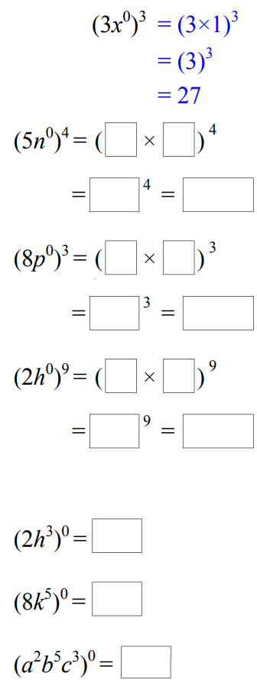
- Study the example and simplify these.

625 | 512 | 512
- ${\left(2h^{0}\right)}^{3}$  8 | - ${\left(8k^{0}\right)}^{2}$  64 | - ${\left(3x^{0}y^{0}\right)}^{4}$  81
- ${\left(2h^{3}\right)}^{0}$  1 | - ${\left(8k^{2}\right)}^{0}$  1 | - ${\left(3x^{2}y^{4}\right)}^{0}$  1

- Simplify these expressions.
- $x^{0}×y^{0}$  1 | - $x^{0}+y^{0}$  2 | - $a^{0}-b^{0}$  0 | - $p×q^{0}$  $$p$$
- $x+y^{0}$  $$x+1$$ | - $2x^{0}+y^{0}$  $$3$$ | - ${\left(2x\right)}^{0}-z^{0}$  0 | - $2p×3q^{0}$  $$6p$$

- Simplify the following.
$$\frac{6x^{2}}{x}$$  $$6x$$ | $$\frac{x^{2}}{6x}$$  $$\frac{x}{6}$$ | $$\frac{x}{6x^{2}}$$  $$\frac{1}{6x}$$ | $$\frac{3x}{6x^{2}}$$  $$\frac{1}{2x}$$
$$\frac{6x^{2}}{3x}$$  $$2x$$ | $$\frac{6x^{2}}{3x^{2}}$$  $$2$$ | $$\frac{9x^{2}}{6x}$$  $$\frac{3x}{2}$$ | $$\frac{9x}{6x^{2}}$$  $$\frac{3}{2x}$$
- $15÷15a^{2}$  $$\frac{1}{a^{2}}$$ | - $2y÷8y^{2}$  $$\frac{1}{4y}$$ | - $8y^{3}÷6y$  $$\frac{4y^{2}}{3}$$ | - $9y^{2}÷12y^{5}$  $$\frac{3}{4y^{3}}$$

- Simplify.
- $\frac{4x^{2}}{8x^{5}}$  $$\frac{1}{2x^{3}}$$ | - $\frac{3m^{2}}{15m^{8}}$  $$\frac{1}{5m^{6}}$$ | - $\frac{7p}{14p^{6}}$  $$\frac{1}{2p^{5}}$$
- $\frac{6a^{3}}{12a^{9}}$  $$\frac{1}{2a^{6}}$$ | - $\frac{5y^{4}}{20y^{10}}$  $$\frac{1}{4y^{6}}$$ | - $\frac{2b^{3}}{16b^{11}}$  $$\frac{1}{8b^{8}}$$

- Simplify these pairs of expressions.
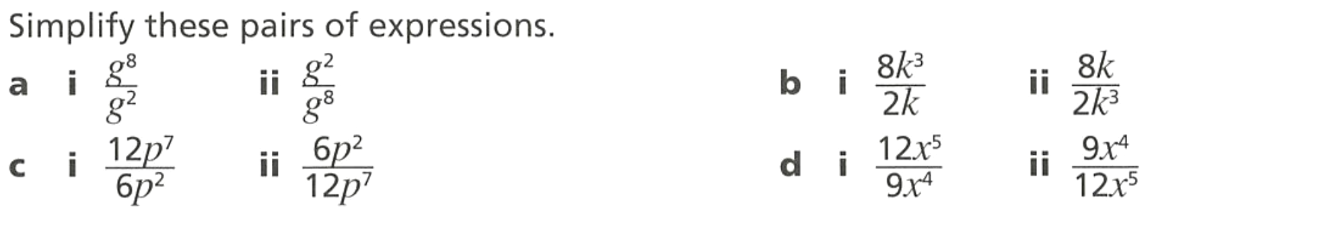  $$g^{6}, \frac{1}{g^{6}}$$ | $$4k^{2}, \frac{4}{k^{2}}$$
$$2p^{5}, \frac{1}{2p^{5}}$$ | $$\frac{4x}{3}, \frac{3}{4x}$$

- Simplify.
- $\frac{6x^{5}×2x^{3}}{4x^{4}}$  $$3x^{4}$$ | - $2x^{3}×6x^{4}÷4x^{2}$  $$3x^{5}$$ | - $5y^{2}×4y^{3}×2y$  $$40y^{6}$$
- $\frac{3a^{2}×4a^{6}}{2a^{3}}$  $$6a^{5}$$ | - $\frac{8m^{9}}{2m^{3}×m^{2}}$  $$4m^{4}$$ | - $\frac{10p^{4}×3p^{5}}{6p^{3}}$  $$5p^{6}$$

- Tammy is trying to simplify $2q^{4}×4q^{5}$

The answer is $6q^{9}$

Explain why she is incorrect and state the correct answer.

We multiply the non-base numbers. $8q^{9}$

- Every answer is incorrect, state the error and write the correct answer.
  - $2x^{3}×3x^{5}=5x^{8}$
Added the coefficients instead of multiplying. Correct: $6x^{8}$
  - $4a^{2}×3a^{5}=12a^{10}$
Multiplied the exponents instead of adding. Correct: $12a^{7}$
  - $\frac{8y^{6}}{2y^{2}}$ $=4y^{3}$
Did not subtract the exponents correctly. Correct: $4y^{4}$
  - $\frac{10m^{4}}{10m^{4}}$ $=0$
Everything cancels, but the answer should be 1.
  - $3p^{2}×5p^{3}=8p^{5}$
Added the coefficients. Correct: $15p^{5}$
  - $-2x^{4}×3x^{2}=6x^{6}$
Forgot the negative sign. Correct: $-6x^{6}$

Index Laws with More than One Variable

- Review
- Recall index laws with coefficients
- $3x^{2}×2x^{3}$ | - $4x^{4}×2x^{3}$ | - $6x^{5}÷2x^{2}$

- Recall implied index of 1
- $x×x^{2}$ | - $y^{5}÷y$ | - $m^{5}×m$

- Simplify by applying index laws to each variable separately
When applying index laws, we apply them to each variable separately
$$x^{2}y^{4}×x^{3}y^{7}$$  $$=x^{5}y^{11}$$ | $$x^{2}y^{4}×x^{3}y$$  $$=x^{5}y^{5}$$ | $$\frac{x^{5}y^{7}}{x^{11}y^{2}}$$  $$=\frac{y^{5}}{x^{6}}$$
Simplify these expressions
- $x^{3}y^{2}×x^{2}y^{4}$ | - $x^{2}y^{3}×yx^{5}$ | - $a^{3}b×ab^{5}$
- $\frac{x^{9}y^{6}}{xy^{2}}$ | - $\frac{x^{9}y^{6}}{x^{12}y^{2}}$ | - $a^{2}b^{3}c×ab^{5}$

- Example Apply index laws to simplify expressions with more than one variable
$$3x²y⁴ × 2x^{3}y$$  $=6x^{5}y^{5}$ | $$\frac{9x^{5}y^{2}}{6x^{2}y^{7}}$$  $$=\frac{3x^{3}}{2y^{5}}$$

- Guided Practice
Simplify
- $6x^{3}y^{7}×2x^{5}y^{2}$  $$12x^{8}y^{9}$$ | - $4c^{4}d×2c^{2}$  $$8c^{6}d$$
- $\frac{12x^{2}y^{11}}{8x^{6}y}$  $$\frac{3y^{10}}{2x^{4}}$$ | - $\frac{{2x^{5}y}^{3}}{14x^{6}y}$  $$\frac{y^{2}}{7x}$$

- Key Ideas
- When multiplying expressions with multiple variables, apply the index law to each variable ………………….

Development
- Simplify:
- $a^{2}b^{3}×a^{4}b$  $$a^{6}b^{4}$$ | - $x^{3}y^{2}×x^{4}y^{6}$  $$x^{7}y^{8}$$ | - $u^{6}v^{2}×u^{2}v^{7}$  $$u^{8}v^{9}$$
- $m^{5}n^{2}×mn^{4}$  $$m^{6}n^{6}$$ | - $h^{2}k^{5}×h^{3}k^{2}$  $$h^{5}k^{7}$$ | - $c^{7}d^{3}×cd^{9}$  $$c^{8}d^{12}$$
- $pq^{3}×p^{2}q^{5}$  $$p^{3}q^{8}$$ | - $r^{4}s×rs^{3}$  $$r^{5}s^{4}$$ | - $w^{4}y^{4}×w^{4}y^{4}$  $$w^{8}y^{8}$$

- Simplify:
- $\frac{a^{7}b^{5}}{a^{3}b^{2}}$  $$a^{4}b^{3}$$ | - $\frac{x^{10}y^{4}}{x^{4}y}$  $$x^{6}y^{3}$$ | - $\frac{r^{5}s^{7}}{rs^{2}}$  $$r^{4}s^{5}$$
- $\frac{m^{8}n^{6}}{m^{5}n^{3}}$  $$m^{3}n^{3}$$ | - $\frac{p^{6}q^{9}}{p^{2}q^{5}}$  $$p^{4}q^{4}$$ | - $\frac{c^{9}d^{12}}{c^{2}d^{4}}$  $$c^{7}d^{8}$$

- Simplify these expressions.
$$f^{6}g$$ | $$\frac{f^{6}}{g}$$ | $$\frac{g}{f^{6}}$$ | $$\frac{1}{f^{6}g}$$

- Simplify:
- $\frac{x^{7}y^{3}}{x^{2}y^{8}}$  $$\frac{x^{5}}{y^{5}}$$ | - $\frac{m^{4}n^{6}}{m^{10}n^{2}}$  $$\frac{n^{4}}{m^{6}}$$ | - $\frac{r^{2}s^{7}}{r^{9}s^{3}}$  $$\frac{s^{4}}{r^{7}}$$
- $\frac{a^{3}b^{9}}{a^{7}b^{5}}$  $$\frac{b^{4}}{a^{4}}$$ | - $\frac{p^{8}q}{p^{2}q^{4}}$  $$\frac{p^{6}}{q^{3}}$$

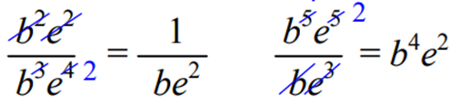
- Simplify. Example:

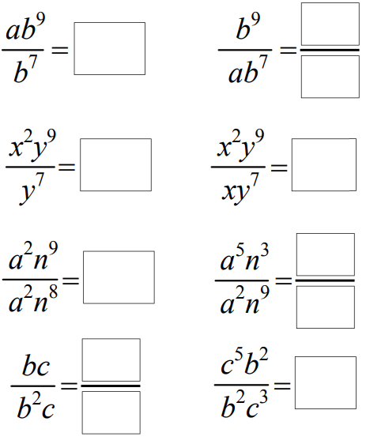  $$ab^{2}$$ | $$\frac{b^{2}}{a}$$ | $$x^{2}y^{2}$$ | $$xy^{2}$$
$$n$$ | $$\frac{a^{3}}{n^{6}}$$ | $$\frac{1}{b}$$ | $$c^{2}$$
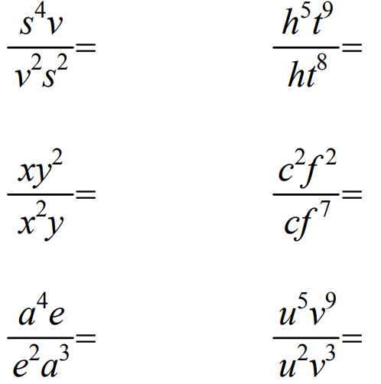  $$\frac{s^{2}}{v}$$ | $$\frac{y}{x}$$ | $$\frac{a}{e}$$ | $$\frac{c}{f^{5}}$$

- Simplify the following expressions.
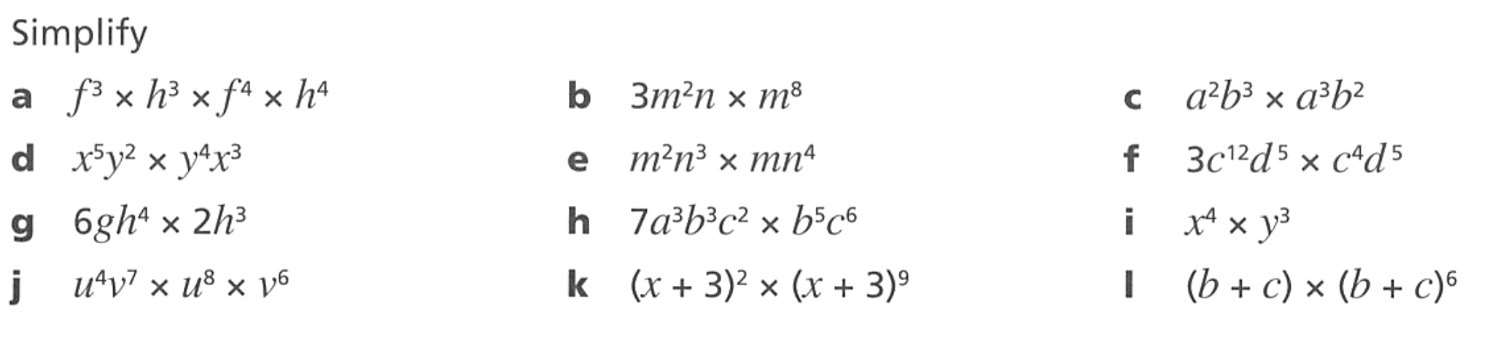  $$f^{7}h^{7}$$ | $$3m^{10}n$$ | $$a^{5}b^{5}$$
$$x^{8}y^{6}$$ | $$m^{3}n^{7}$$ | $$3c^{16}d^{10}$$
$$12gh^{7}$$ | $$7a^{3}b^{8}c^{8}$$ | $$x^{4}y^{3}$$
$$u^{12}v^{13}$$ | $${\left(x+3\right)}^{11}$$ | $${\left(b+c\right)}^{7}$$

- Simplify the following using index laws.
- $x^{3}y^{3}×x^{4}y^{2}$  $$x^{7}y^{5}$$ | - $-x^{7}y^{3}×x^{2}y$  $$-x^{9}y^{4}$$ | - $5x^{3}y^{5}×xy^{4}$  $$5x^{4}y^{9}$$
- $xy^{4}z×4xy$  $$4x^{2}y^{5}z$$ | - $-3m^{3}×5m^{2}$  $$-15m^{5}$$ | - $4e^{2}f^{2}×2e^{2}f^{2}$  $$8e^{4}f^{4}$$
- $5c^{4}d×4c^{3}d$  $$20c^{7}d^{2}$$ | - $-9yz^{2}×-2yz^{5}$  $$18y^{2}z^{7}$$ | - $6m^{12}×3mn$  $$18m^{13}n$$
- $3x^{4}×2x^{3}×3x$  $$18x^{8}$$ | - $-9x^{5}×3x^{2}$  $$-27x^{7}$$ | - $\left(-3m^{3}n^{2}\right)×(-4mn^{7})$  $$12m^{4}n^{9}$$
- Simplify these expressions.
$$5m^{5}n$$ | $$\frac{3a^{3}b^{2}}{2}$$ | $$\frac{2h^{4}}{5}$$ | $$\frac{10x}{y^{2}}$$

- Simplify:
- $3x^{2}y×4x^{3}y^{4}$  $$12x^{5}y^{5}$$ | - $\frac{12m^{7}n^{4}}{4m^{2}n}$  $$3m^{5}n^{3}$$ | - $2xy^{3}×6x^{4}y$  $$12x^{5}y^{4}$$
- $5a^{4}b^{2}×2ab^{5}$  $$10a^{5}b^{7}$$ | - $\frac{20p^{3}q^{5}}{5pq^{2}}$  $$4p^{2}q^{3}$$ | - $\frac{15a^{9}b^{3}}{3a^{4}b^{2}}$  $$5a^{5}b$$

- Simplify the following using index laws.
- $\frac{5w^{2}x^{5}}{25wx^{3}}$  $$\frac{wx^{2}}{5}$$ | - $\frac{7m^{7}y^{4}}{21m^{2}y^{2}}$  $$\frac{m^{5}y^{2}}{3}$$ | - $\frac{6a^{6}b^{16}}{a^{3}b^{7}}$  $$6a^{3}b^{9}$$
- $\frac{16x^{8}y^{6}}{12x^{2}y^{3}}$  $$\frac{4x^{6}y^{3}}{3}$$ | - $\frac{6s^{6}t^{3}}{14s^{5}t}$  $$\frac{3st^{2}}{7}$$ | - $-\frac{5x^{2}y}{xy}$  $$-5x$$

- Expand these brackets.
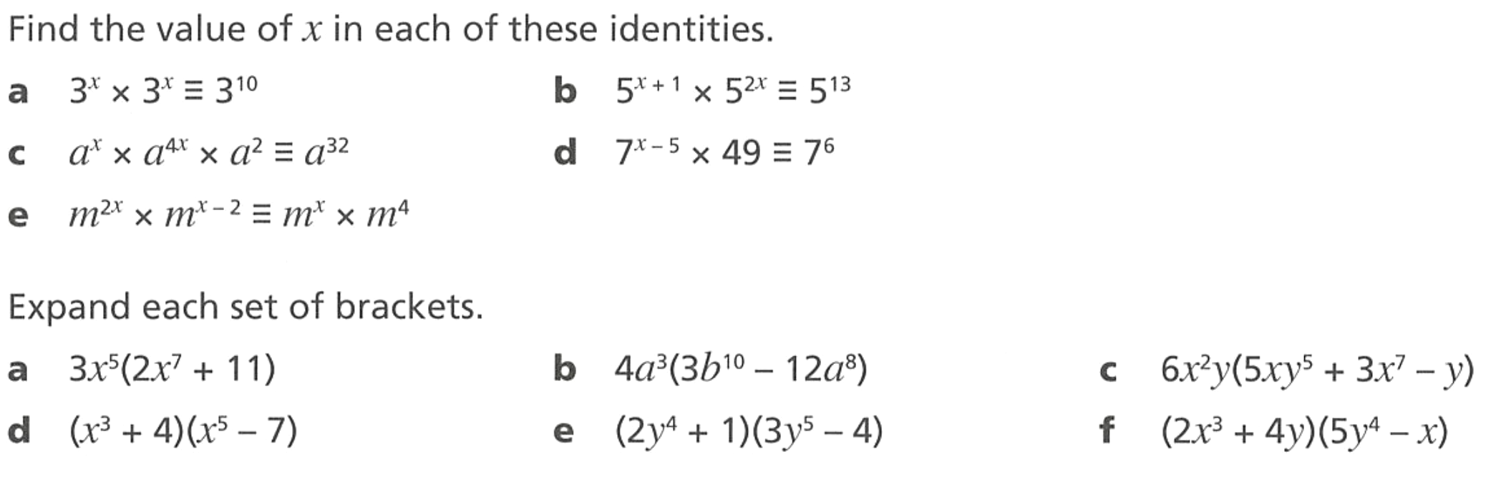  $$6x^{12}+33x^{5}$$ | $$12a^{3}b^{10}-48a^{11}$$ | $$30x^{3}y^{6}+18x^{9}y-6x^{2}y^{2}$$

Mixed Practice: Basic Index Laws

Foundation
- Write each of the following in index form.
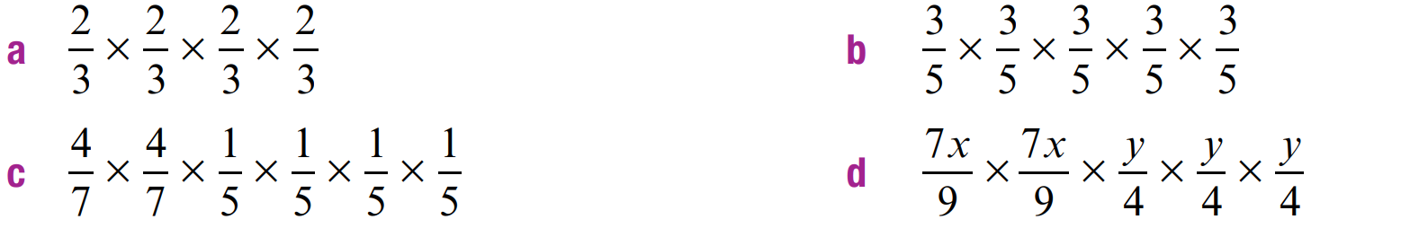  $${\left(\frac{2}{3}\right)}^{4}$$ | $${\left(\frac{3}{5}\right)}^{5}$$
$${\left(\frac{4}{7}\right)}^{2}{\left(\frac{1}{5}\right)}^{4}$$ | $${\left(\frac{7x}{9}\right)}^{2}{\left(\frac{y}{4}\right)}^{3}$$

- Find the missing numbers.
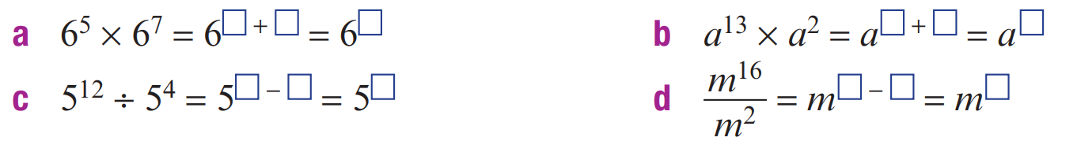  $$6^{12}$$ | $$a^{15}$$
$$5^{8}$$ | $$m^{14}$$

- Simplify
- $x^{4}×x^{3}$  $$x^{7}$$ | - $b^{6}×b^{4}$  $$b^{10}$$ | - $h×h^{7}$  $$h^{8}$$ | - $w^{9}÷w^{5}$  $$w^{4}$$
- $\frac{a^{7}}{a^{2}}$  $$a^{5}$$ | - $\frac{c^{3}}{c^{9}}$  $$\frac{1}{c^{6}}$$ | - $\frac{m^{10}}{m^{4}}$  $$m^{6}$$ | - $\frac{x^{2}}{x^{8}}$  $$\frac{1}{x^{6}}$$
- $(y^{3})^{2}$  $$y^{6}$$ | - $(p^{5})^{4}$  $$p^{20}$$ | - $(q^{2})^{6}$  $$q^{12}$$ | - $(t^{4})^{3}$  $$t^{12}$$
- $5m^{0}$  $$5$$ | - $(7n)^{0}$  $$1$$ | - $-3r^{0}$  $$-3$$ | - $(2a)^{0}+1$  $$2$$
- $4x^{2}×3x^{5}$  $$12x^{7}$$ | - $\frac{12a^{8}}{4a^{3}}$  $$3a^{5}$$ | - $5x^{3}y^{2}×2xy^{4}$  $$10x^{4}y^{6}$$ | - $\frac{18m^{7}}{6m^{3}}$  $$3m^{4}$$

- Simplify  $$4y^{3}×2y^{8}$$  $$8y^{11}$$ | - Work out the value of  $\left(4×{10}^{3}\right)×\left(2×{10}^{8}\right)$  $$8×{10}^{11}$$
- Simplify  $$\frac{4y^{3}}{2y^{8}}$$  $$\frac{2}{y^{5}}$$ | - Work out the value of  $$\frac{4×{10}^{3}}{2×{10}^{8}}$$  $$\frac{2}{{10}^{5}}$$

- Simplify these expressions using the index laws.
- $x^{4}×x^{3}$  $$x^{7}$$ | - $a^{6}×a^{3}$  $$a^{9}$$ | - $t^{5}×t^{3}$  $$t^{8}$$
- $a^{6}÷a^{4}$  $$a^{2}$$ | - $x^{5}÷x^{2}$  $$x^{3}$$ | - $\frac{q^{12}}{q^{2}}$  $$q^{10}$$
- ${\left(x^{3}\right)}^{5}$  $$x^{15}$$ | - ${\left(x^{7}\right)}^{3}$  $$x^{21}$$ | - $x^{0}$  $$1$$
- $y×y^{4}$  $$y^{5}$$ | - $d^{2}×d$  $$d^{3}$$ | - $\frac{d^{7}}{d^{6}}$  $$d$$
- ${\left(y^{7}\right)}^{0}$  $$1$$ | - $2x^{0}$  $$2$$ | - $\frac{e^{5}}{e^{0}}$  $$e^{5}$$
- $y^{2}×y×y^{4}$  $$y^{7}$$ | - $b×b^{5}×b^{2}$  $$b^{8}$$ | - $\frac{8b^{10}}{4b^{5}}$  $$2b^{5}$$
- $\frac{12d^{10}}{36d^{5}}$  $$\frac{d^{5}}{3}$$ | - $q^{6}×q^{3}×q^{2}$  $$q^{11}$$ | - $\frac{4a^{14}}{2a^{7}}$  $$2a^{7}$$
- $\frac{18y^{15}}{9y^{7}}$  $$2y^{8}$$ | - $\frac{9y^{7}}{18y^{15}}$  $$\frac{1}{2y^{8}}$$ | - $9m^{3}÷m^{2}$  $$9m$$
- $5y^{4}÷y^{2}$  $$5y^{2}$$ | - $\frac{3m^{7}}{12m^{2}}$  $$\frac{m^{5}}{4}$$ | - $\frac{4a^{4}}{20a^{3}}$  $$\frac{a}{5}$$

- Simplify the following.
- ${\left(y^{6}\right)}^{2}$  $$y^{12}$$ | - ${\left(m^{3}\right)}^{6}$  $$m^{18}$$ | - ${\left(x^{2}\right)}^{5}$  $$x^{10}$$
- $5^{0}$  $$1$$ | - ${\left(-6\right)}^{0}$  $$1$$ | - $5{\left(m^{8}\right)}^{2}$  $$5m^{16}$$
- $4{\left(q^{7}\right)}^{4}$  $$4q^{28}$$ | - ${\left(-3\right)}^{0}$  $$1$$ | - $-{\left(4\right)}^{0}$  $$-1$$
- $-3{\left(c^{2}\right)}^{5}$  $$-3c^{10}$$ | - $2{\left(j^{4}\right)}^{6}$  $$2j^{24}$$ | - $-3p^{0}$  $$-3$$
- ${\left(0.75\right)}^{0}$  $$1$$ | - ${\left(\frac{3}{4}\right)}^{0}$  $$1$$ | - ${\left(4y\right)}^{0}$  $$1$$
- $5m^{0}$  $$5$$ | - $-3p^{0}$  $$-3$$ | - $6x^{0}-2x^{0}$  $$4$$
- $-5n^{0}-{\left(8n\right)}^{0}$  $$-6$$ | - ${\left(3x^{4}\right)}^{0}$  $$1$$ | - $1^{0}+2^{0}+3^{0}$  $$3$$
- ${\left(1+2+3\right)}^{0}$  $$1$$ | - ${100}^{0}-a^{0}$  $$0$$ | - ${\left(-5\right)}^{0}$  $$1$$

- Simplify
- $\frac{6x^{4}y^{3}}{2xy}$  $$3x^{3}y^{2}$$ | - $-2x^{3}×5x^{2}$  $$-10x^{5}$$ | - $4ab^{3}×3a^{4}b$  $$12a^{5}b^{4}$$ | - $(c^{4})^{2}×(c^{3})^{2}$  $$c^{14}$$
- $3a^{2}b×4a^{3}b^{2}$  $$12a^{5}b^{3}$$ | - $\frac{a^{7}b^{3}}{a^{2}b^{5}}$  $$\frac{a^{5}}{b^{2}}$$ | - $\frac{15x^{6}y^{2}}{3x^{2}y^{4}}$  $$\frac{5x^{4}}{y^{2}}$$ | - $\frac{m^{9}n^{4}}{m^{4}n^{9}}$  $$\frac{m^{5}}{n^{5}}$$
- $(m^{2})^{4}×m^{3}$  $$m^{11}$$ | - $(y^{3})^{5}÷y^{10}$  $$y^{5}$$ | - $h^{4}×(h^{2})^{3}$  $$h^{10}$$ | - $9x^{0}y×2y^{3}$  $$18y^{4}$$
- $\frac{20p^{9}}{5p^{4}}$  $$4p^{5}$$ | - $7m^{0}+3n^{0}$  $$10$$ | - $\frac{-6p^{5}}{2p^{2}}$  $$-3p^{3}$$
- Simplify these expressions.
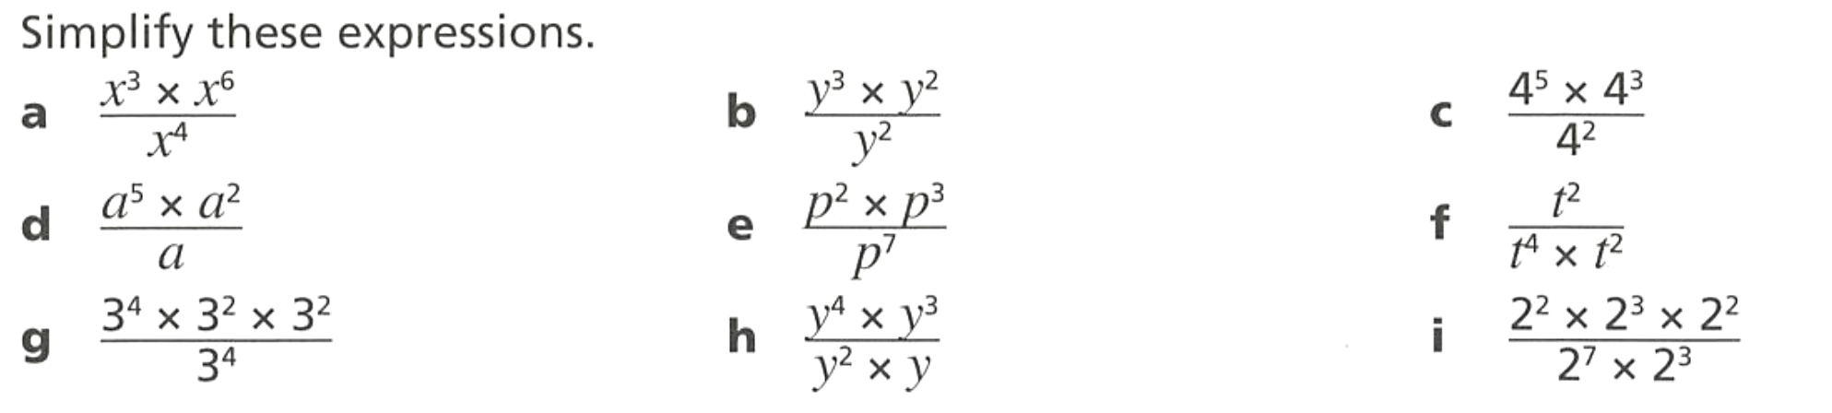  $$x^{5}$$ | $$y^{3}$$ | $$4^{6}$$
$$a^{6}$$ | $$\frac{1}{p^{2}}$$ | $$\frac{1}{t^{4}}$$
$$3^{4}$$ | $$y^{4}$$ | $$\frac{1}{2^{3}}$$

- Simplify
$$5^{26}$$ | $$m^{14}$$ | 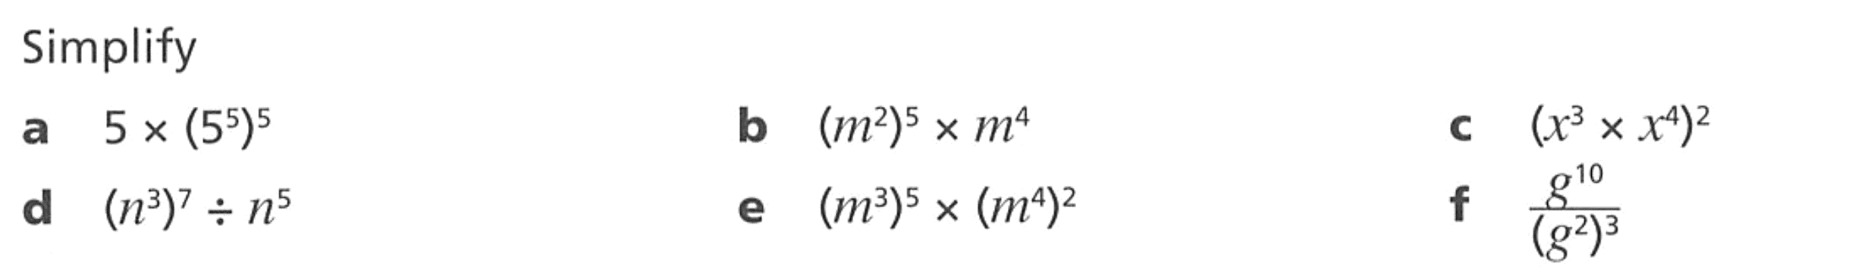  $$x^{14}$$
$$n^{16}$$ | $$m^{23}$$ | $$g^{4}$$

- Simplify  $$\frac{9y^{4}}{3y^{7}}$$  $$\frac{3}{y^{3}}$$ | - Simplify  $$9y^{4}×3y^{7}$$  $$27y^{11}$$
- Work out the value of  $$\left(9×{10}^{4}\right)×\left(3×{10}^{7}\right)$$  $$27×{10}^{11}$$ | - Simplify  $$\frac{9×{10}^{4}}{3×{10}^{7}}$$  $$\frac{3}{{10}^{3}}$$

- Simplify these expressions.
- ${\left(-x\right)}^{0}$  1 | - $-x^{0}$  $$-1$$ | - $w^{0}-x^{0}$  0 | - $s^{0}-{(-x)}^{0}$  0
- $w^{0}+{\left(-x\right)}^{0}$  2 | - ${\left(-w\right)}^{0}+{\left(-x\right)}^{0}$  2 | - $-w^{0}+{\left(-x\right)}^{0}$  0 | - $-w^{0}-x^{0}$  $$-2$$

- Find the missing numbers.
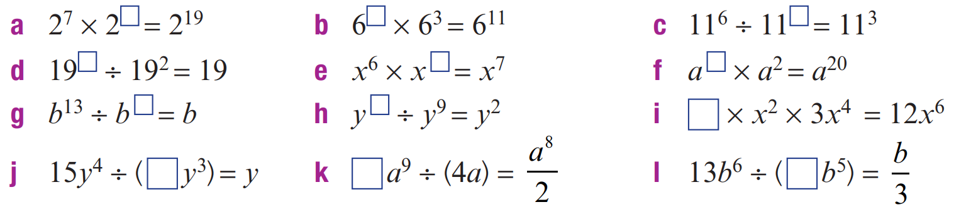  12 | 8 | 3
3 | 1 | 18
12 | 11 | 4
15 | 2 | 39

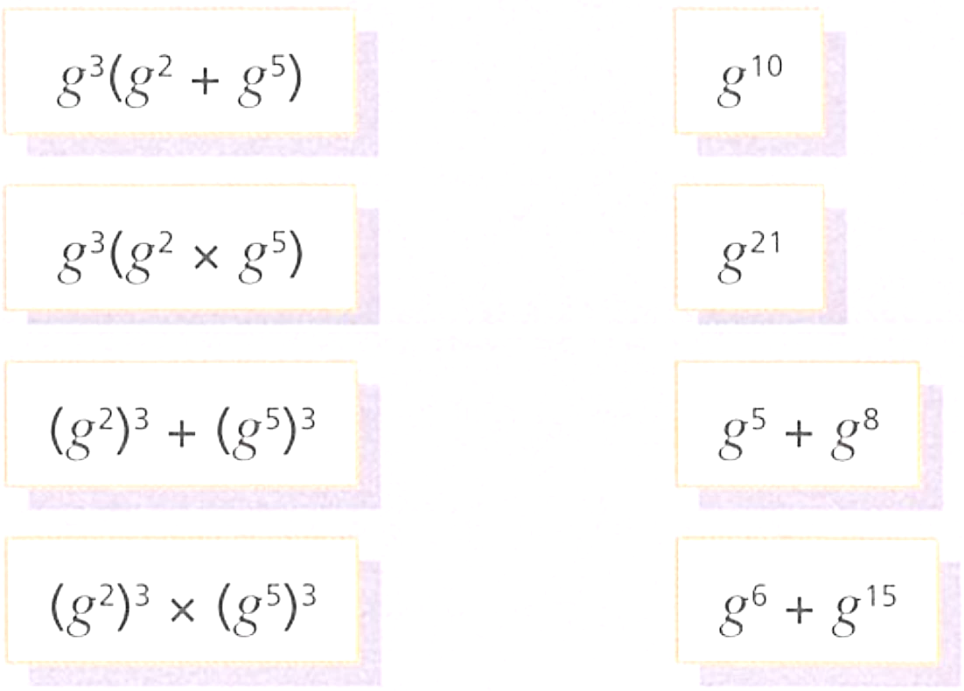
- Match the cards.
a
b
c
d
A
B
C
D

a – C, b – A, c – D, d – B

- Simplify each of the following by combining various index laws
- $4×{\left(4^{3}\right)}^{2}$  $$4^{7}$$ | - ${\left(3^{4}\right)}^{2}×3$  $$3^{9}$$ | - $x×{\left(x^{0}\right)}^{5}$  $$x$$
- $7^{8}÷{\left(7^{3}\right)}^{2}$  $$7^{2}$$ | - ${\left(4^{2}\right)}^{3}÷4^{5}$  $$4$$ | - ${\left(3^{6}\right)}^{3}÷{\left(3^{5}\right)}^{2}$  $$3^{8}$$
- $y^{5}×{\left(y^{2}\right)}^{4}$  $$y^{13}$$ | - $b^{5}×{\left(b^{3}\right)}^{3}$  $$b^{14}$$ | - ${\left(a^{2}\right)}^{3}×a^{4}$  $$a^{10}$$
- ${\left(m^{3}\right)}^{6}÷{\left(m^{2}\right)}^{9}$  $$1$$ | - ${\left(y^{5}\right)}^{3}÷{\left(y^{6}\right)}^{2}$  $$y^{3}$$ | - ${\left(h^{11}\right)}^{2}÷{\left(h^{5}\right)}^{4}$  $$h^{2}$$
- $a^{3}f×{\left(a^{4}\right)}^{2}×{\left(f^{4}\right)}^{3}$  $$a^{11}f^{13}$$ | - $x^{2}y×{\left(x^{3}\right)}^{4}×{\left(y^{2}\right)}^{2}$  $$x^{14}y^{5}$$ | - ${\left(s^{2}\right)}^{3}×5{\left(r^{0}\right)}^{3}×rs^{2}$  $$5rs^{8}$$

- Simplify these expressions.
- $\frac{a^{3}×a^{5}}{a^{6}}$  $$a^{2}$$ | - $2x^{3}×3x^{5}$  $$6x^{8}$$
- $\frac{a^{6}}{a^{3}×a^{5}}$  $$\frac{1}{a^{2}}$$ | - $2x^{3}y^{2}×3x^{5}y^{2}$  $$6x^{8}y^{4}$$
- $\frac{x^{6}}{a^{3}×a^{5}}$  $$\frac{x^{6}}{a^{8}}$$ | - $12x^{6}y^{2}×3x^{5}y^{2}$  $$36x^{11}y^{4}$$
- $\frac{12x^{6}}{2a^{3}×3a^{5}}$  $$\frac{2x^{6}}{a^{8}}$$ | - $12x^{6}y^{2}÷3x^{5}y^{2}$  $$4x$$
- $\frac{12x^{6}}{2x^{3}×3x^{5}}$  $$\frac{2}{x^{2}}$$ | - $\frac{12x^{6}y^{8}}{3x^{5}y^{2}}$  $$4xy^{6}$$

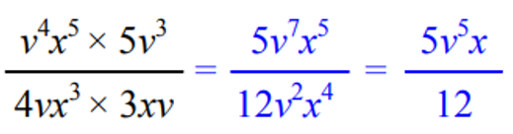
- Look at the example and then answer the questions.

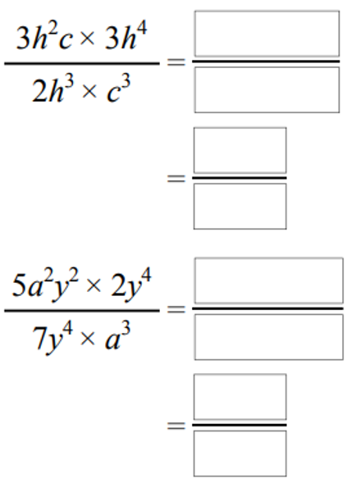  $$\frac{9h^{3}}{2c^{2}}$$ | $$\frac{10y^{2}}{7a}$$ | 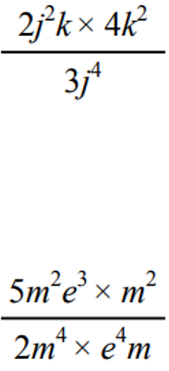  $$\frac{8k^{3}}{3j^{2}}$$

- Read the example carefully and answer the questions.
Liz’s work  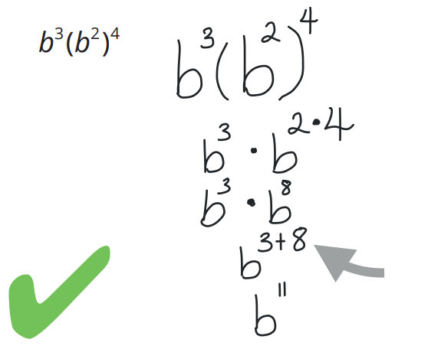  Write as an expression without brackets: | In the step marked with an arrow, why did Liz add instead of multiply?  Index law of multiplication says to add  Simplify  $${\left(r^{5}\right)}^{2}r^{3}$$  $$r^{13}$$

- These simplifications are not correct. Provide the correct answer.
- $a^{4}×a=a^{4}$  $$a^{5}$$ | - $x^{7}÷x=x^{7}$  $$x^{6}$$ | - $3a^{5}÷6a^{3}=2a^{2}$  $\frac{a^{2}}{2}$
- $5x^{7}÷10x^{3}=$ $\frac{1}{2x^{4}}$  $$\frac{x^{4}}{2}$$ | - $2x^{7}×3x^{4}=5x^{11}$  $$6x^{11}$$ | - $a^{5}÷a^{2}×a=a^{5}÷a^{3}$  $$a^{4}$$
- ${\left(a^{4}\right)}^{5}=a^{9}$  $$a^{20}$$ | - $3{\left(x^{3}\right)}^{2}=9x^{6}$  $$3x^{6}$$ | - ${\left(-2x\right)}^{0}=-2$  $$1$$

  - Simplify
$$\frac{{\left(a^{3}\right)}^{2}×a^{4}}{{\left(a^{2}\right)}^{5}}$$
1
  - Does the value of $a$ matter?

no
- NAPLAN B
Simplify the expression $\frac{{\left(12x\right)}^{0}}{4}×\frac{5x}{3}$

$$\frac{5x}{12}$$
- NAPLAN B
Simplify the expression $\frac{{20m}^{0}}{n}×\frac{n^{2}}{5m}$
$$\frac{4n}{m}$$

- Simplify these expressions.
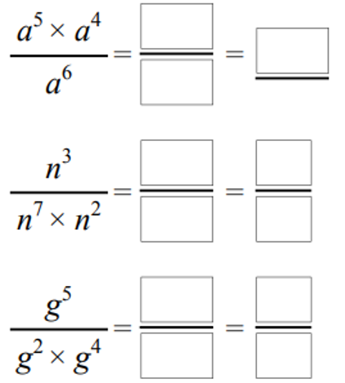  $$a^{3}$$ | $$\frac{1}{n^{6}}$$ | $$\frac{1}{g}$$
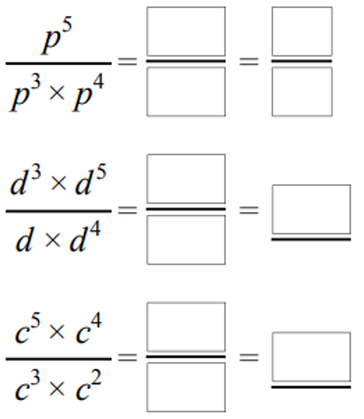  $$\frac{1}{p^{2}}$$ | $$d^{3}$$ | $$c^{4}$$
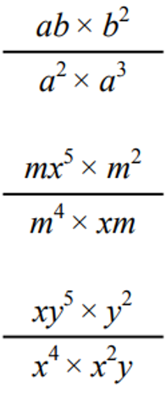  $$\frac{b^{3}}{a^{4}}$$ | $$\frac{x^{4}}{m^{2}}$$ | $$\frac{y^{6}}{x^{5}}$$
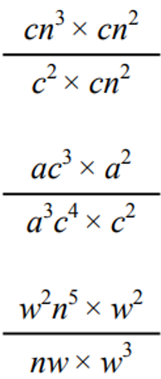  $$\frac{n^{3}}{c}$$ | $$\frac{1}{c^{3}}$$ | $$n^{4}$$
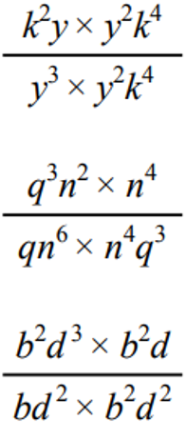  $$\frac{k^{2}}{y^{2}}$$ | $$\frac{1}{qn^{4}}$$ | $$b$$
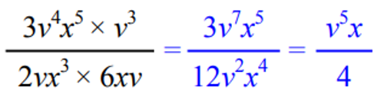
- Look at the example and then answer the questions.

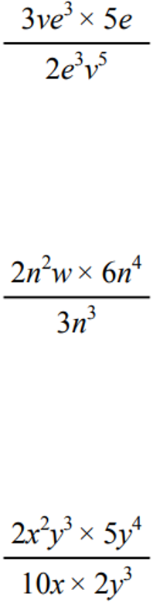  $$\frac{15e}{2v^{4}}$$ | $$4n^{3}w$$ | $$\frac{xy^{4}}{2}$$
$$\frac{5}{2me}$$ | 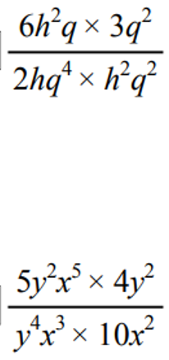  $$\frac{9}{hq^{3}}$$ | $$2$$

- Simplify each of the following by combining various index laws
- $\frac{{\left(b^{2}\right)}^{5}}{b^{4}}$  $$b^{6}$$ | - $\frac{{\left(x^{4}\right)}^{3}}{x^{7}}$  $$x^{5}$$ | - $\frac{{\left(y^{3}\right)}^{3}}{y^{3}}$  $$y^{6}$$
- $\frac{3x^{4} × 6x^{3}}{9x^{12}}$  $$\frac{2}{x^{5}}$$ | - $\frac{5x^{5} × 4x^{2}}{2x^{10}}$  $$\frac{10}{x^{3}}$$ | - $\frac{24{\left(x^{4}\right)}^{4}}{8{\left(x^{4}\right)}^{2}}$  $$3x^{8}$$
- $\frac{4{\left(d^{4}\right)}^{3} × {\left(e^{4}\right)}^{2}}{8{\left(d^{2}\right)}^{5} × e^{7}}$  $$\frac{d^{2}e}{2}$$ | - $\frac{6{\left(m^{3}\right)}^{2}{\left(n^{5}\right)}^{3}}{15{\left(m^{5}\right)}^{0}{\left(n^{2}\right)}^{7}}$  $$\frac{2m^{6}n}{5}$$ | - $\frac{2{\left(a^{3}\right)}^{4}{\left(b^{2}\right)}^{6}}{16{\left(a\right)}^{0}{\left(b^{6}\right)}^{2}}$  $$\frac{a^{12}}{8}$$

- Simplify the following using index laws.
- $b^{5}×b^{2}÷b$  $$b^{6}$$ | - $y^{5}×y^{4}÷y^{3}$  $$y^{6}$$ | - $c^{4}÷c×c^{4}$  $$c^{7}$$
- $x^{4}×x^{2}×x^{5}$  $$x^{11}$$ | - $\frac{t^{4} × t^{3}}{t^{6}}$  $$t$$ | - $\frac{p^{2} × p^{7}}{p^{3}}$  $$p^{6}$$
- $\frac{d^{5} × d^{3}}{d^{2}}$  $$d^{6}$$ | - $\frac{x^{9} × x^{2}}{x}$  $$x^{10}$$ | - $\frac{3x^{3}y^{4} × 8xy}{6x^{2}y^{2}}$  $$4x^{2}y^{3}$$
- $\frac{9b^{4}}{{2g}^{3}}×\frac{4g^{4}}{3b^{2}}$  $$6b^{2}g$$ | - $\frac{24m^{7}n^{5}}{5m^{3}n}×\frac{5m^{2}n^{4}}{8mn^{2}}$  $$3m^{5}n^{6}$$ | - $\frac{p^{4}q^{3}}{p^{2}q}×\frac{p^{6}q^{4}}{p^{3}q^{2}}$  $$p^{5}q^{4}$$

- Simplify $\frac{5ab^{2}}{2ab^{2}}÷\frac{10a^{4}b^{7}}{4a^{3}b^{8}}$

$$\frac{b}{a}$$

  - Rhys picks two cards and then divides the expressions. He gets the answer $y^{3}$.
Which two cards does he pick? Find two different answers.

$$10y^{4}÷10y, 12y^{3}÷12$$
  - Huda picks two cards and then divides the expressions. She gets the answer $\frac{3}{y^{2}}$.
Which two cards does she pick?

$$18y^{6}÷6y^{8}$$

- Find the missing terms.
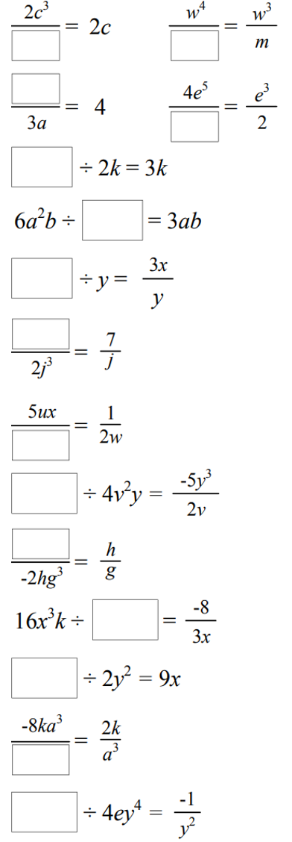  $$c^{2}$$ | $$wm$$ | $$12a$$ | $$8e^{2}$$
$$6k^{2}$$ | $$2a$$ | $$3x$$ | $$14j^{2}$$
$$10uxw$$ | $$-20vy^{4}$$ | $$-2h^{2}g^{2}$$ | $$-6x^{4}k$$
$$18xy^{2}$$ | $$-4a^{6}$$ | $$-4ey^{2}$$

- Given that $\frac{y^{n}×y^{5}}{y^{6}}$ $=y^{13}$, work out the value of $n$.

14
- Find the value of $n$
$$\frac{{\left(x^{-6}\right)}^{5}}{x^{4}}=x^{n}$$

$$-34$$
- Evaluate without a calculator.
- ${\left(2^{4}\right)}^{8}÷2^{30}$  4 | - ${\left({10}^{3}\right)}^{7}÷{10}^{18}$  1000 | - ${\left(7^{4}\right)}^{9}÷7^{36}$  1
- ${\left({\left(-1\right)}^{11}\right)}^{2}÷{\left({\left(-1\right)}^{2}\right)}^{11}$  1 | - $-2{\left({\left(-2\right)}^{3}\right)}^{3}÷{\left(-2\right)}^{8}$  4 | - $\frac{{\left(5^{2}\right)}^{3}}{{\left(8^{4}\right)}^{7}}×\frac{{\left(8^{7}\right)}^{4}}{{\left(5^{3}\right)}^{2}}$  1

- Split these expressions according to prime factors.
- $6^{n}$  $={\left(2×3\right)}^{n}$  $=2^{n}×3^{n}$ | - ${21}^{y}$  $$3^{y}×7^{y}$$ | - ${12}^{x}$  $$2^{2x}×3^{x}$$
- ${10}^{x+y}$  $$2^{x+y}×5^{x+y}$$ | - ${35}^{2x+3}$  $$5^{2x+3}×7^{2x+3}$$ | - ${26}^{4x-3z}$  $$2^{4x-3z}×{13}^{4x-3z}$$

- Simplify the following.
- $\frac{3a^{5}bc^{3}}{6a^{4}c}×\frac{4b^{3}}{2abc}×\frac{2a^{3}b^{2}c}{2a^{2}b^{4}c^{2}}$  $$ab$$ | - $\frac{3a^{4}b^{5}}{a^{5}b^{2}}÷\frac{6b^{3}}{2a^{2}b}$  $$ab$$ | - $\frac{2a}{3a^{2}b^{3}}×\frac{9a^{4}b^{7}}{ab^{5}}÷\frac{6a}{b^{2}}$  $$ab$$

- Expand:
- $6a^{2}\left(2a-4a^{3}\right)$  $$12a^{3}-24a^{5}$$ | - $c^{\frac{3}{2}}\left(c^{\frac{1}{2}}+c^{-\frac{3}{2}} \right)$  $$c^{2}+1$$ | - $-6a^{2}b^{3}c\left(2a^{3}b+a^{2}bc^{-1}\right)$  $$-12a^{5}b^{4}c-6a^{4}b^{4}$$

- Simplify
$$\frac{3x^{-\frac{5}{4}}×4x^{\frac{7}{4}}}{x^{\frac{3}{2}}}$$

$$\frac{12}{x} or 12x^{-1}$$
- Solve $3^{x}×3^{x+3}=81$

$$x=0.5$$
- Solve to find $x$
$${\left(m^{\frac{3}{11}}\right)}^{x}=m^{\frac{5}{9}}$$

$$\frac{55}{27}$$

Power of a Product

- Review
- Simplify expressions using index law of multiplication
- $3x×3x$ | - ${\left(3x\right)}^{2}$ | - $2x^{5}×2x^{5}×2x^{5}$ | - ${\left(2x^{5}\right)}^{3}$
- Evaluate powers
- $2^{3}$ | - ${\left(-2\right)}^{3}$ | - $5^{3}$
- ${\left(-5\right)}^{2}$ | - $3^{2}$ | - ${\left(-3\right)}^{3}$

- Power of a Product
$${\left(ab\right)}^{m}=a^{m}b^{m}$$

- Simplify Power of a product
When there is a product inside brackets, we apply the power to each factor inside brackets.
$${\left(5b\right)}^{2}$$  $$=5^{2}b^{2}$$ | $$5b^{2}$$  $$=5b^{2}$$ |  | $${\left(3x^{2}y\right)}^{4}$$  $$=3^{4}x^{8}y^{4}$$ | $$2{\left(xy^{2}\right)}^{3}$$  $$=2x^{3}y^{6}$$ |  | $$4xy^{3}$$  $$=4{xy}^{3}$$
Simplify the following expressions:

- ${\left(2a\right)}^{3}$ |  | - $3a^{2}$ |  |  | - ${\left(3a^{2}\right)}^{4}$
- $4{\left(b^{2}c\right)}^{3}$ |  | - ${\left(xy\right)}^{4}$ |  |  | - $5xy^{4}$
- Example Simplify expressions using power of a product
Simplify
${(5b)}^{3}$  $=5^{3}b^{3}$  $=125b^{3}$ |  | ${\left(-3x^{4}y\right)}^{2}$  $={\left(-3\right)}^{2}x^{8}y^{2}$  $=9x^{8}y^{2}$ |  |  | $4x{\left(c^{2}d^{3}\right)}^{5}$  $=4xc^{10}d^{15}$

- Guided Practice
Simplify
- $(2x)^{4}$  $$16x^{4}$$ | - $(3y^{2})^{3}$  $$27y^{6}$$
- $(-4a)^{2}$  $$16a^{2}$$ | - $(2a^{2}b)^{3}$  $$8a^{6}b^{3}$$
- $3(x^{2})^{4}$  $$3x^{8}$$ | - Compare $(3x)^{2}$ and $3x^{2}$  $$9x^{2}, 3x^{2}$$

- Key Ideas
- When raising a product to a power, the power applies to ………… factor inside brackets.
- ${\left(2xy^{2}z\right)}^{3}=$ …………
- $2x{\left(y^{2}z\right)}^{3}=$ ……………

Foundation
- Complete the following
$$5^{3}×a^{3}$$ | 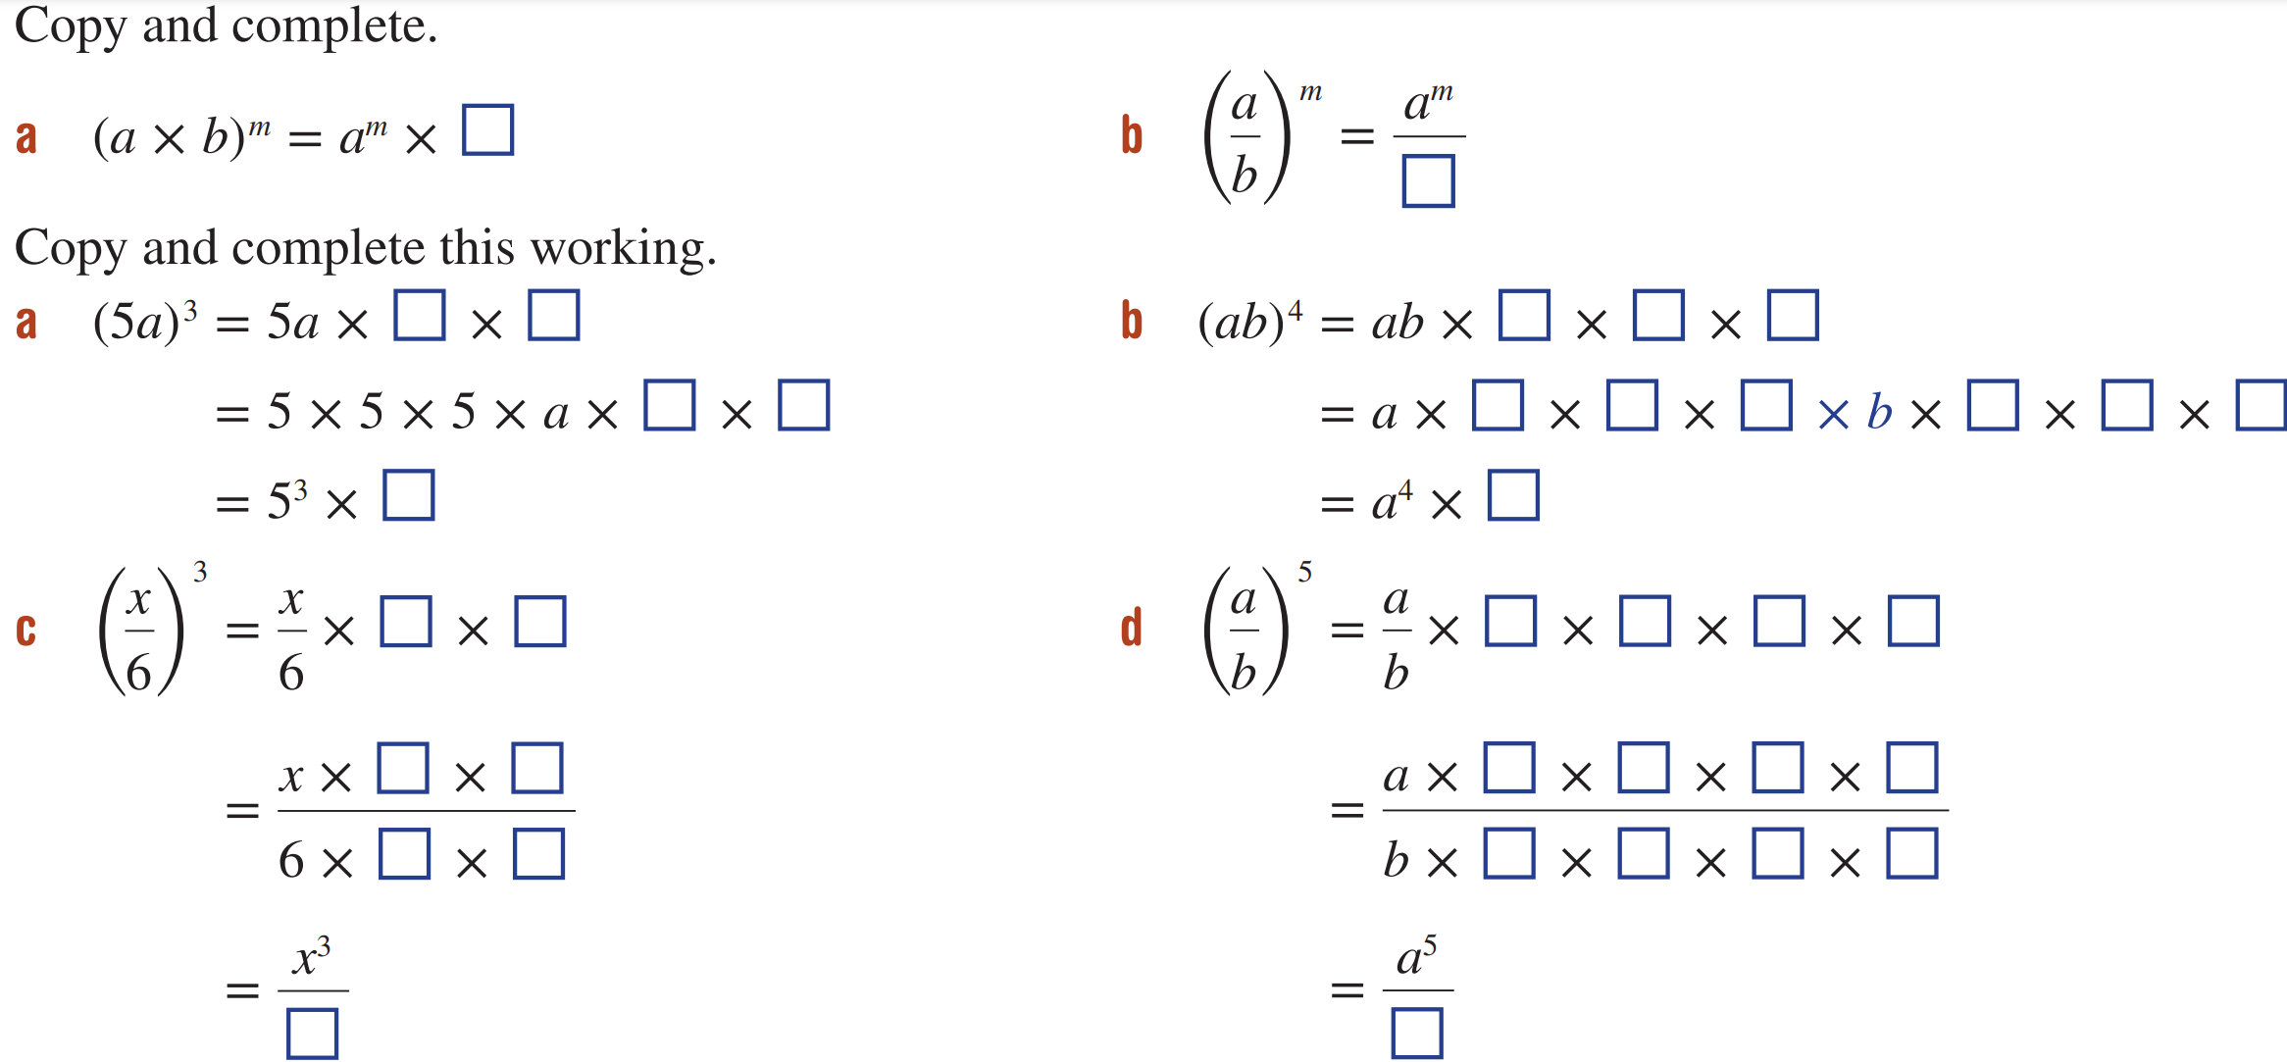  $$a^{4}×b^{4}$$

- Simplify these expressions by expanding first, then multiplying.
$${\left(2x^{4}\right)}^{3}=2x^{4}×2x^{4}×2x^{4}$$  $=2^{3}x^{12}=$ ………… | 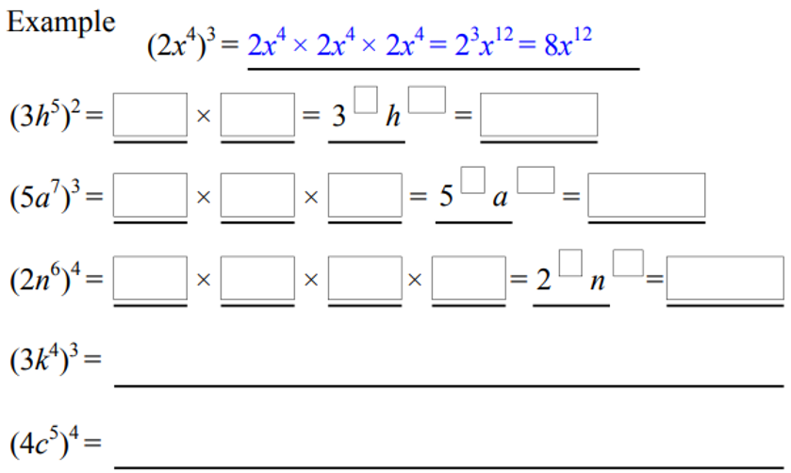  $$9h^{10}$$
$$125a^{21}$$ | $$16n^{24}$$

- Simplify
- $(2x)^{3}$  $$8x^{3}$$ | - $(4x)^{2}$  $$16x^{2}$$ | - $(6y)^{2}$  $$36y^{2}$$ | - $(3b)^{3}$  $$27b^{3}$$
- $(3x)^{2}$  $$9x^{2}$$ | - $(5x)^{3}$  $$125x^{3}$$ | - $(2a)^{4}$  $$16a^{4}$$ | - $(10c)^{2}$  $$100c^{2}$$

- Simplify
- $(ab)^{3}$  $$a^{3}b^{3}$$ | - $(mn)^{5}$  $$m^{5}n^{5}$$ | - $(3xy)^{2}$  $$9x^{2}y^{2}$$ | - $(xy^{2})^{3}$  $$x^{3}y^{6}$$
- $(xy)^{4}$  $$x^{4}y^{4}$$ | - $(2ab)^{3}$  $$8a^{3}b^{3}$$ | - $(a^{2}b)^{4}$  $$a^{8}b^{4}$$ | - $(2a^{2}b^{3})^{3}$  $$8a^{6}b^{9}$$

- Simplify
- $(x^{2})^{3}$  $$x^{6}$$ | - $(3a^{2})^{2}$  $$9a^{4}$$ | - $(5y^{3})^{2}$  $$25y^{6}$$ | - $(2q^{3})^{4}$  $$16q^{12}$$
- $(2x^{2})^{3}$  $$8x^{6}$$ | - $(2m^{4})^{3}$  $$8m^{12}$$ | - $(4p^{5})^{2}$  $$16p^{10}$$ | - $(3r^{2})^{3}$  $$27r^{6}$$

Development
- Simplify these expressions using the rule.
${\left(2x^{4}\right)}^{3}=2^{3}x^{12}=$ …………… | 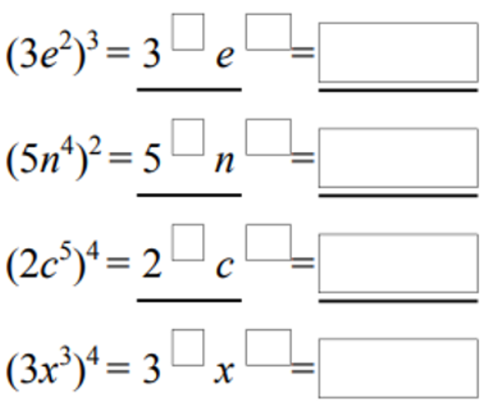  $$27e^{6}$$ | $$25n^{8}$$
$$16c^{20}$$ | $$81x^{12}$$ | ${\left(3k^{4}\right)}^{3}=$  $$27k^{12}$$
${\left(4c^{5}\right)}^{4}=$  $$256c^{20}$$ | ${\left(6v^{5}\right)}^{3}=$  $$216v^{15}$$ | ${\left(10a^{8}\right)}^{5}=$  $$100 000a^{40}$$

  - Complete the following:

$$x^{9}y^{6}$$
  - Simplify these expressions
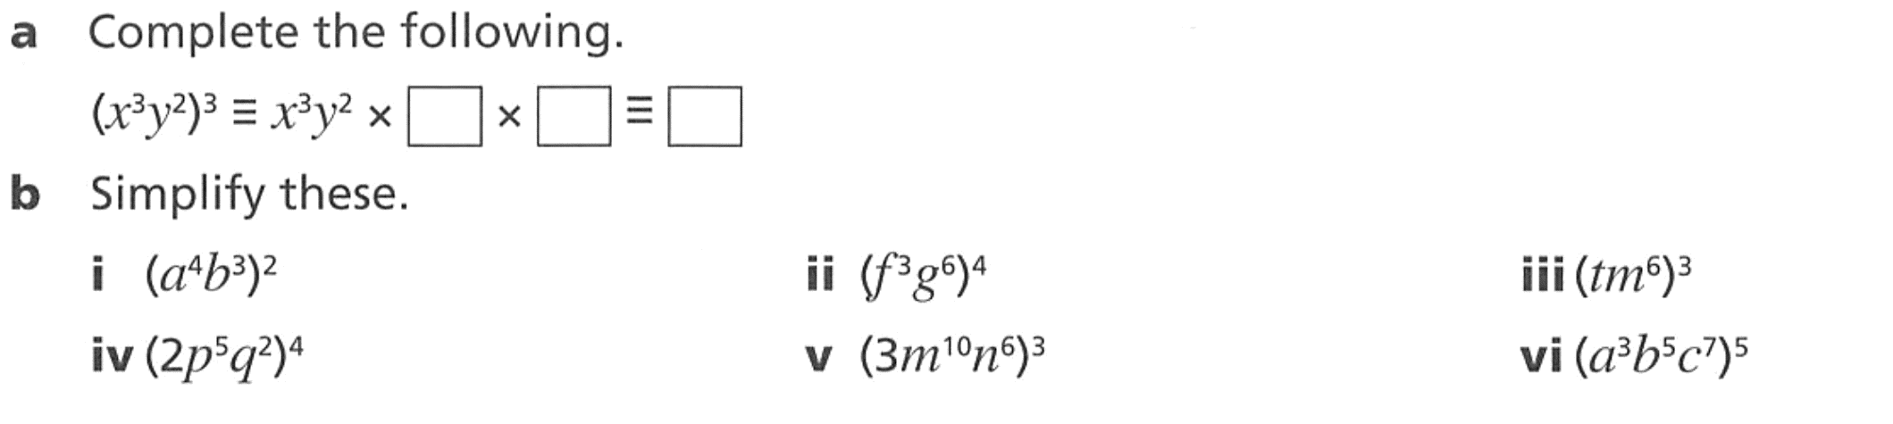  $$a^{8}b^{6}$$ | $$f^{12}g^{24}$$ | $$t^{3}m^{18}$$
$$16p^{20}q^{8}$$ | $$27m^{30}n^{18}$$ | $$a^{15}b^{25}c^{35}$$

- Simplify.
- ${\left(2x\right)}^{3}$  $$8x^{3}$$ | - ${\left(5y\right)}^{2}$  $$25y^{2}$$ | - ${\left(4a^{2}\right)}^{3}$  $$64a^{6}$$ | - ${\left(-3r\right)}^{2}$  $$9r^{2}$$
- ${\left(a^{3}b\right)}^{5}$  $$a^{15}b^{5}$$ | - ${\left(x^{3}y^{2}\right)}^{4}$  $$x^{12}y^{8}$$ | - ${\left(c^{10}e^{2}\right)}^{8}$  $$c^{80}e^{16}$$ | - ${\left(a^{4}b^{2}c\right)}^{5}$  $$a^{20}b^{10}c^{5}$$
- ${\left(3x^{5}\right)}^{2}$  $$9x^{10}$$ | - ${\left(2x^{3}\right)}^{4}$  $$16x^{12}$$ | - ${\left(5p^{3}\right)}^{3}$  $$125p^{9}$$ | - ${\left(\frac{1}{2}g^{4}\right)}^{3}$  $$\frac{g^{12}}{8}$$
- $-{\left(3r\right)}^{2}$  $$-9r^{2}$$ | - ${\left(-2h^{2}\right)}^{4}$  $$16h^{8}$$ | - ${\left(5c^{2}d^{3}\right)}^{4}$  $$625c^{8}d^{12}$$ | - ${\left(2x^{3}y^{2}\right)}^{5}$  $$32x^{15}y^{10}$$

Mastery
- Read the example carefully and answer the questions.
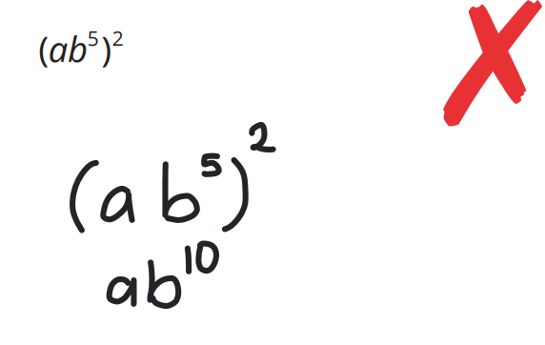 | By expanding and writing out ${\left(ab^{5}\right)}^{2}$, show why this is wrong.  $$ab^{5}×ab^{5}=a^{2}b^{10}$$  Simplify ${\left(cj^{3}\right)}^{5}$  $$c^{5}j^{15}$$
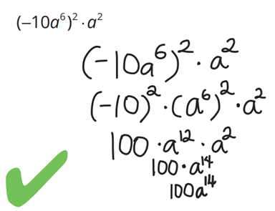 | Explain why we need brackets for ${\left(-10\right)}^{2}$.  Without brackets, $-{10}^{2}=-100$  Simplify  $${\left(-2b^{3}\right)}^{2}×b^{4}$$  $$4b^{10}$$

- Simplify.
- $(-2x)^{2}$  $$4x^{2}$$ | - $(-3a)^{2}$  $$9a^{2}$$ | - $(-5y^{2})^{2}$  $$25y^{4}$$ | - $(-2p^{4})^{3}$  $$-8p^{12}$$
- $(-2x)^{3}$  $$-8x^{3}$$ | - $(-3a)^{3}$  $$-27a^{3}$$ | - $(-4m^{3})^{2}$  $$16m^{6}$$ | - $(-y)^{5}$  $$-y^{5}$$

- Simplify
- $2(x^{2})^{3}$  $$2x^{6}$$ | - $5(m^{3})^{2}$  $$5m^{6}$$ | - $2(pq)^{4}$  $$2p^{4}q^{4}$$ | - $-2(x^{3})^{4}$  $$-2x^{12}$$
- $3(a^{4})^{2}$  $$3a^{8}$$ | - $4(y^{5})^{3}$  $$4y^{15}$$ | - $3(a^{2}b)^{3}$  $$3a^{6}b^{3}$$ | - $5(2x)^{3}$  $$40x^{3}$$

- Find the area of these squares.
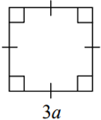  ${\left(3a\right)}^{2}=$ ………………  $$9a^{2}$$ | 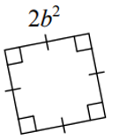  $$4b^{4}$$ | 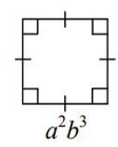  $$a^{4}b^{6}$$ | 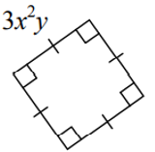  $$9x^{4}y^{2}$$

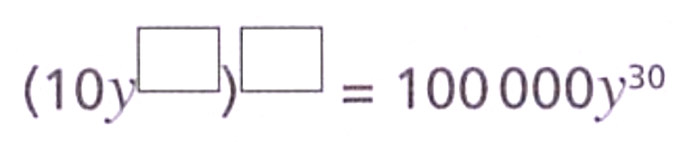
- Find the missing numbers.

$${\left(10y^{6}\right)}^{5}$$
- Simplify these pairs of expressions.
- $4x^{2} and {\left(4x\right)}^{2}$  $$4x^{2}, 16x^{2}$$ | - $-6y^{2} and (-6y)^{2}$  $$-6y^{2}, 36y^{2}$$
- $-2a^{3} and {\left(-2a\right)}^{3}$  $$-2a^{3}, -8a^{3}$$ | - $-3{\left(x^{2}y\right)}^{3} and x^{2}{\left(-3y\right)}^{3}$  $$-3x^{6}y^{3}, -27x^{2}y^{3}$$

- Use two methods to simplify these expressions. The first is done for you.
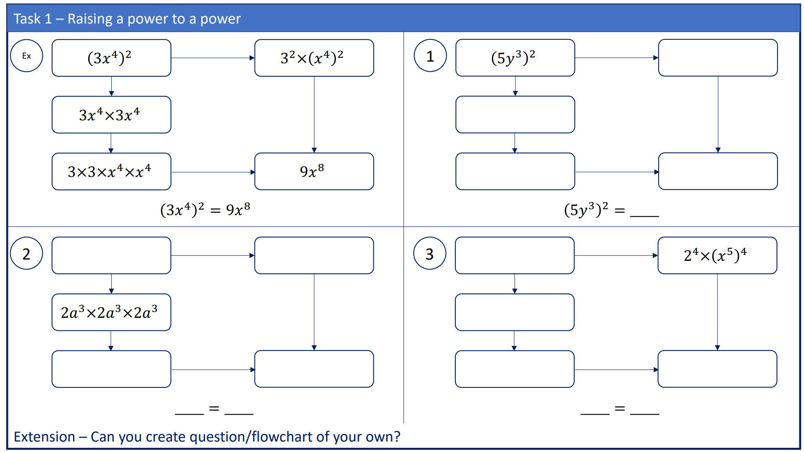 | Top to bottom:  $$5^{2}×{\left(y^{3}\right)}^{2}$$  $$5y^{3}×5y^{3}$$  $$5×5×y^{3}×y^{3}, 25y^{6}$$
$${\left(2a^{3}\right)}^{3}, 2^{3}×{\left(a^{3}\right)}^{3}$$  $$2×2×2×a^{3}×a^{3}×a^{3}, 8a^{9}$$  $${\left(2a^{3}\right)}^{3}=8a^{9}$$ | $${\left(2x^{5}\right)}^{4}$$  $$2x^{5}×2x^{5}×2x^{5}×2x^{5}$$  $$2×2×2×2×x^{5}×x^{5}×x^{5}×x^{5}, 16x^{20}$$  $${\left(2x^{5}\right)}^{4}=16x^{20}$$

- Expand then simplify these expressions.
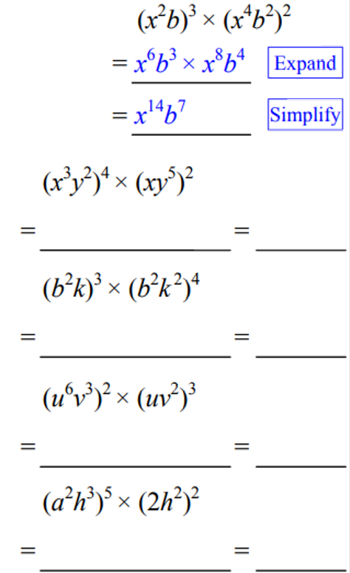 | $$x^{14}y^{18}$$ | $$b^{14}k^{11}$$
$$u^{15}v^{12}$$ | $$4a^{10}h^{19}$$

Power of a Quotient

- Review
- Simplify expressions using index law of multiplication
- $\frac{x}{3}×\frac{x}{3}$ | - ${\left(\frac{x}{3}\right)}^{2}$ | - $\frac{2}{x^{5}}×\frac{2}{x^{5}}×\frac{2}{x^{5}}$ | - ${\left(\frac{2}{x^{5}}\right)}^{3}$
- Evaluate powers
- ${\left(\frac{1}{2}\right)}^{3}$ | - ${\left(\frac{2}{3}\right)}^{3}$ | - ${\left(\frac{3}{5}\right)}^{2}$

- Power of a Quotient
$${\left(\frac{a}{b}\right)}^{m}=\frac{a^{m}}{b^{m}}$$

- Simplify Power of a quotient
For fractions inside brackets, we apply the power to each term in numerator and denominator.
$${\left(\frac{x}{y}\right)}^{3}$$  $$=\frac{x^{3}}{y^{3}}$$ | $${\left(\frac{ab^{2}}{c^{4}}\right)}^{3}$$  $$=\frac{a^{3}b^{6}}{c^{12}}$$ | $${x\left(\frac{a^{2}}{b^{5}}\right)}^{4}$$  $$=\frac{xa^{8}}{b^{20}}$$
Simplify the following expressions:

- ${\left(\frac{a}{b}\right)}^{4}$ | - ${\left(\frac{x^{2}}{y}\right)}^{5}$ | - ${\left(\frac{pq^{2}}{r^{11}}\right)}^{9}$
- $2{\left(\frac{a}{b}\right)}^{4}$ | - $3x{\left(\frac{a}{b}\right)}^{5}$ | - $2x{\left(\frac{a^{2}}{b^{7}}\right)}^{3}$
- Example Simplify expressions using power of a product
Simplify
$${\left(\frac{6}{b}\right)}^{3}=\frac{6^{3}}{b^{3}}$$  $$=\frac{216}{b^{3}}$$ | $${\left(\frac{ab^{2}}{c^{4}}\right)}^{4}=\frac{a^{4}b^{8}}{c^{16}}$$ | $${\left(\frac{-2}{3b}\right)}^{4}=\frac{{(-2)}^{4}}{3^{4}b^{4}}$$  $$=\frac{16}{81b^{4}}$$

- Guided Practice
Simplify
- ${\left(\frac{p}{q}\right)}^{2}$  $$\frac{p^{2}}{q^{2}}$$ | - ${\left(\frac{4}{y}\right)}^{3}$  $$\frac{64}{y^{3}}$$
- ${\left(\frac{-5}{p^{2}}\right)}^{4}$  $$\frac{625}{p^{8}}$$ | - ${\left(\frac{2x}{y}\right)}^{5}$  $$\frac{32x^{5}}{y^{5}}$$
- $3$ ${\left(\frac{n^{3}}{2m}\right)}^{2}$  $$\frac{3n^{6}}{4m^{2}}$$ | - ${\left(\frac{-3f}{2g^{2}}\right)}^{3}$  $$\frac{-27f^{3}}{8g^{6}}$$

- Key Ideas
- When raising a fraction to a power, the power applies to both the ………………… and …………………

Foundation
- Complete the following
$$\frac{x^{3}}{6^{3}}$$ | $$\frac{a^{5}}{b^{5}}$$

- Simplify
- ${\left(\frac{a}{b}\right)}^{3}$  $$\frac{a^{3}}{b^{3}}$$ | - ${\left(\frac{m}{n}\right)}^{2}$  $$\frac{m^{2}}{n^{2}}$$ | - ${\left(\frac{c}{d}\right)}^{6}$  $$\frac{c^{6}}{d^{6}}$$
- ${\left(\frac{x}{y}\right)}^{4}$  $$\frac{x^{4}}{y^{4}}$$ | - ${\left(\frac{p}{q}\right)}^{5}$  $$\frac{p^{5}}{q^{5}}$$ | - ${\left(\frac{r}{s}\right)}^{3}$  $$\frac{r^{3}}{s^{3}}$$

- Simplify
- ${\left(\frac{2}{x}\right)}^{3}$  $$\frac{8}{x^{3}}$$ | - ${\left(\frac{4}{y}\right)}^{2}$  $$\frac{16}{y^{2}}$$ | - ${\left(\frac{x}{2}\right)}^{4}$  $$\frac{x^{4}}{16}$$
- ${\left(\frac{3}{a}\right)}^{2}$  $$\frac{9}{a^{2}}$$ | - ${\left(\frac{5}{m}\right)}^{3}$  $$\frac{125}{m^{3}}$$ | - ${\left(\frac{a}{3}\right)}^{3}$  $$\frac{a^{3}}{27}$$

- Simplify
- ${\left(\frac{p}{q}\right)}^{3}$  $$\frac{p^{3}}{q^{3}}$$ | - ${\left(\frac{x}{y}\right)}^{4}$  $$\frac{x^{4}}{y^{4}}$$ | - ${\left(\frac{4}{y}\right)}^{3}$  $$\frac{64}{y^{3}}$$
- ${\left(\frac{5}{p^{2}}\right)}^{4}$  $$\frac{625}{p^{8}}$$ | - ${\left(\frac{2}{r^{3}}\right)}^{2}$  $$\frac{4}{r^{6}}$$ | - ${\left(\frac{s^{3}}{7}\right)}^{2}$  $$\frac{s^{6}}{49}$$
- ${\left(\frac{2m}{n}\right)}^{5}$  $$\frac{32m^{5}}{n^{5}}$$ | - ${\left(\frac{2a^{2}}{3}\right)}^{3}$  $$\frac{8a^{6}}{27}$$ | - ${\left(\frac{3n^{3}}{2m^{4}}\right)}^{3}$  $$\frac{27n^{9}}{8m^{12}}$$

Development
- Simplify
- ${\left(\frac{x^{2}}{y}\right)}^{3}$  $$\frac{x^{6}}{y^{3}}$$ | - ${\left(\frac{m^{4}}{n^{2}}\right)}^{3}$  $$\frac{m^{12}}{n^{6}}$$ | - ${\left(\frac{x^{3}}{y^{3}}\right)}^{2}$  $$\frac{x^{6}}{y^{6}}$$
- ${\left(\frac{a}{b^{3}}\right)}^{2}$  $$\frac{a^{2}}{b^{6}}$$ | - ${\left(\frac{p^{2}}{q^{5}}\right)}^{4}$  $$\frac{p^{8}}{q^{20}}$$ | - ${\left(\frac{c^{2}d}{e^{3}}\right)}^{2}$  $$\frac{c^{4}d^{2}}{e^{6}}$$

- Simplify
- ${\left(\frac{3x}{2y}\right)}^{2}$  $$\frac{9x^{2}}{4y^{2}}$$ | - ${\left(\frac{4m}{n}\right)}^{2}$  $$\frac{16m^{2}}{n^{2}}$$ | - ${\left(\frac{2x^{2}}{3y}\right)}^{2}$  $$\frac{4x^{4}}{9y^{2}}$$
- ${\left(\frac{2a}{5b}\right)}^{3}$  $$\frac{8a^{3}}{125b^{3}}$$ | - ${\left(\frac{p}{3q}\right)}^{3}$  $$\frac{p^{3}}{27q^{3}}$$ | - ${\left(\frac{5a}{2b^{3}}\right)}^{2}$  $$\frac{25a^{2}}{4b^{6}}$$

- Simplify
- ${\left(\frac{-2}{x}\right)}^{2}$  $$\frac{4}{x^{2}}$$ | - ${\left(\frac{-3a}{b}\right)}^{2}$  $$\frac{9a^{2}}{b^{2}}$$ | - ${\left(\frac{-1}{2m}\right)}^{3}$  $$-\frac{1}{8m^{3}}$$
- ${\left(\frac{-2}{x}\right)}^{3}$  $$-\frac{8}{x^{3}}$$ | - ${\left(\frac{-x}{y}\right)}^{4}$  $$\frac{x^{4}}{y^{4}}$$ | - ${\left(\frac{-3}{2a^{2}}\right)}^{2}$  $$\frac{9}{4a^{4}}$$

- Read the example carefully and answer the questions.
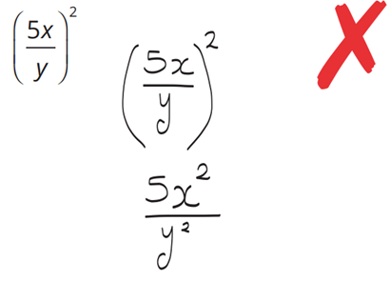 | There is something wrong with the 5 in the answer. What should there be instead?  25  Write as an expression without brackets:  $${\left(\frac{3a}{b}\right)}^{4}$$  $$\frac{81a^{4}}{b^{4}}$$

Mastery
- Simplify these fractions without a calculator. The first one is done for you.
- $\frac{2^{4}}{6^{4}}$ $=$ ${\left(\frac{2}{6}\right)}^{4}$  $$={\left(\frac{1}{3}\right)}^{4}$$  $$=\frac{1}{81}$$ | - $\frac{6^{3}}{3^{3}}$  8 | - $\frac{{10}^{4}}{5^{4}}$  16 | - $\frac{3^{3}}{{30}^{3}}$  $$\frac{1}{1000}$$

- Solve these equations.
- ${\left(\frac{a}{3}\right)}^{2}$ $=$ $\frac{25}{9}$  $$a=±5$$ | - ${\left(\frac{a}{2}\right)}^{4}$ $=16$  $$a=±4$$ | - ${\left(5a\right)}^{3}=1000$  $$a=2$$
- ${\left(2a\right)}^{4}=256$  $$a=±2$$ | - ${\left(\frac{2a}{5}\right)}^{2}$ $=$ $\frac{36}{25}$  $$a=±3$$ | - ${\left(\frac{6a}{7}\right)}^{3}$ $=1728$  $$a=\sqrt[3]{2744}=14$$

- The rule for the number of seeds germinating in a glass house over a two-week period is given by $N={\left(\frac{t}{2}\right)}^{3}$, where $N$ is the number of germinating seeds and $t$ is the number of days.
  - Find the number of germinating seeds after:
    - 4 days
8
    - 10 days
125
  - Rewrite the rule without brackets using index laws
$$N=\frac{t^{3}}{8}$$
  - Use your rule in part b to find the number of days required to germinate:
    - 64 seeds
$$t=\sqrt[3]{512}=8$$
    - 1 seed
$$t=\sqrt[3]{8}=2$$

Mixed Practice: Power of a Product and Quotient

Foundation
- Simplify:
- $(3x)^{2}$  $$9x^{2}$$ | - ${\left(\frac{x}{2}\right)}^{3}$  $$\frac{x^{3}}{8}$$ | - ${\left(\frac{2m}{n}\right)}^{2}$  $$\frac{4m^{2}}{n^{2}}$$ | - $\frac{15p^{8}}{5p^{3}}$  $$3p^{5}$$
- ${\left(\frac{a}{b}\right)}^{3}$  $$\frac{a^{3}}{b^{3}}$$ | - $(p^{4})^{3}$  $$p^{12}$$ | - $h^{5}×h^{4}$  $$h^{9}$$ | - $(xy^{2})^{3}$  $$x^{3}y^{6}$$
- $5m^{4}×2m^{3}$  $$10m^{7}$$ | - $(4b)^{0}$  $$1$$ | - $(c^{3}d)^{2}$  $$c^{6}d^{2}$$ | - ${\left(\frac{3}{x}\right)}^{2}$  $$\frac{9}{x^{2}}$$
- $(2y^{3})^{2}$  $$4y^{6}$$ | - $\frac{x^{3}}{x^{9}}$  $$\frac{1}{x^{6}}$$ | - $7x^{0}+2$  $$9$$ | - $3a^{2}b×4ab^{5}$  $$12a^{3}b^{6}$$
- $\frac{12a^{6}}{4a^{2}}$  $$3a^{4}$$ | - $(-2a)^{3}$  $$-8a^{3}$$ | - ${\left(\frac{a^{2}}{b}\right)}^{4}$  $$\frac{a^{8}}{b^{4}}$$ | - $(-3m^{2})^{2}$  $$9m^{4}$$

- Simplify:
- $(2x^{2}y)^{3}$  $$8x^{6}y^{3}$$ | - ${\left(\frac{x^{3}}{y^{2}}\right)}^{3}$  $$\frac{x^{9}}{y^{6}}$$ | - ${\left(\frac{2x^{2}}{3y}\right)}^{3}$  $$\frac{8x^{6}}{27y^{3}}$$ | - $(2a^{2})^{3}×(3a)^{2}$  $$72a^{8}$$
- ${\left(\frac{3a}{2b}\right)}^{2}$  $$\frac{9a^{2}}{4b^{2}}$$ | - $-4(a^{2})^{3}$  $$-4a^{6}$$ | - $\frac{(3m^{2}n)^{2}}{3mn}$  $$3m^{3n}$$ | - ${\left(\frac{-3m}{n^{2}}\right)}^{2}$  $$\frac{9m^{2}}{n^{4}}$$
- $\frac{(2x)^{3}}{x}$  $$8x^{2}$$ | - $\frac{(5p^{2})^{2}}{5p}$  $$5p^{3}$$ | - $(-2x)^{4}×x^{3}$  $$16x^{7}$$ | - $\frac{(4x^{2}y)^{2}}{2xy}$  $$8x^{3y}$$
- $(3m)^{2}×m^{4}$  $$9m^{6}$$ | - $(2ab)^{3}×(ab)^{2}$  $$8a^{5}b^{5}$$ | - $\frac{(x^{3})^{2}×x^{4}}{x^{5}}$  $$x^{5}$$

Development
- Simplify each of the following.
- $2{\left(x^{3}y\right)}^{2}$  $$2x^{6}y^{2}$$ | - ${\left(8t^{2}u^{9}v^{4}\right)}^{0}$  $$1$$ | - ${\left(-3w^{3}y\right)}^{3}$  $$-27w^{9}y^{3}$$ | - ${5\left(v^{4}x^{2}\right)}^{3}$  $$5v^{12}x^{6}$$
- $-4{\left(p^{4}qr\right)}^{2}$  $$-4p^{8}q^{2}r^{2}$$ | - ${\left(-5s^{7}t\right)}^{2}$  $$25s^{14}t^{2}$$ | - ${\left(\frac{5w^{4}y}{2x^{3}}\right)}^{2}$  $$\frac{25w^{8}y^{2}}{4x^{6}}$$ | - ${\left(\frac{-3x}{2y^{3}g^{5}}\right)}^{2}$  $$\frac{9x^{2}}{4y^{6}g^{10}}$$
- ${\left(3q^{6}e^{4}\right)}^{4}$  $$81q^{24}e^{16}$$ | - ${\left(\frac{3km^{3}}{4n^{7}}\right)}^{3}$  $$\frac{27k^{3}m^{9}}{64n^{21}}$$ | - ${10\left(3me^{5}\right)}^{2}$  $$90m^{2}e^{10}$$ | - ${\left(\frac{-2r}{n}\right)}^{4}$  $$\frac{16r^{4}}{n^{4}}$$
- $-{\left(-2x^{4}yz^{3}\right)}^{3}$  $$8x^{12}y^{3}z^{9}$$ | - ${\left(\frac{-3f}{2^{3}g^{5}}\right)}^{2}$  $$\frac{9f^{2}}{64g^{10}}$$ | - $-{\left(\frac{-5w^{4}y}{2zx^{3}}\right)}^{2}$  $$-\frac{25w^{8}y^{2}}{4x^{6}z^{2}}$$ | - $2{\left(r^{2}d^{2}\right)}^{8}$  $$2r^{16}d^{16}$$
- $a{\left(3b\right)}^{2}$  $$9ab^{2}$$ | - $9{\left(p^{2}q^{4}\right)}^{3}$  $$9p^{6}q^{12}$$ | - $a{\left(3b^{2}\right)}^{3}$  $$27ab^{6}$$ | - $-2y{\left(10x^{2}ny^{3}\right)}^{3}$  $$-2000x^{6}n^{3}y^{10}$$
- ${-4w\left(q^{5}xk^{4}\right)}^{5}$  $$-4wq^{25}x^{5}k^{20}$$ | - $2x{\left(7x^{5}b^{3}y\right)}^{2}$  $$98x^{11}b^{6}y^{2}$$ | - $-3{\left(2a^{3}b^{4}\right)}^{2}a^{2}$  $$-12a^{8}b^{8}$$ | - $2{\left(3x^{2}y^{3}\right)}^{3}$  $$54x^{6}y^{9}$$
- ${\left(-4b^{2}c^{5}d\right)}^{3}$  $$-64b^{6}c^{15}d^{3}$$ | - $a{\left(2a\right)}^{3}$  $$8a^{4}$$ | - $5a^{3}{\left(-2a^{4}b\right)}^{3}$  $$-40a^{15}b^{3}$$ | - $-2{\left(-2^{3}x^{4}yz^{3}\right)}^{3}$  $$1024x^{12}y^{3}z^{9}$$

- Simplify each of the following.
- $\frac{{\left(2m^{3}n\right)}^{3}}{m^{4}}$  $$8m^{5}n^{3}$$ | - $\frac{{3\left(2^{2}c^{4}d^{5}\right)}^{3}}{{\left(2cd^{2}\right)}^{4}}$  $$12c^{8}d^{7}$$ | - $\frac{-5{\left(3^{5}m^{3}n^{2}\right)}^{2}}{{\left({-3^{3}m}^{2}n\right)}^{3}}$  $$15n$$

mastery
- Expand then simplify these expressions.
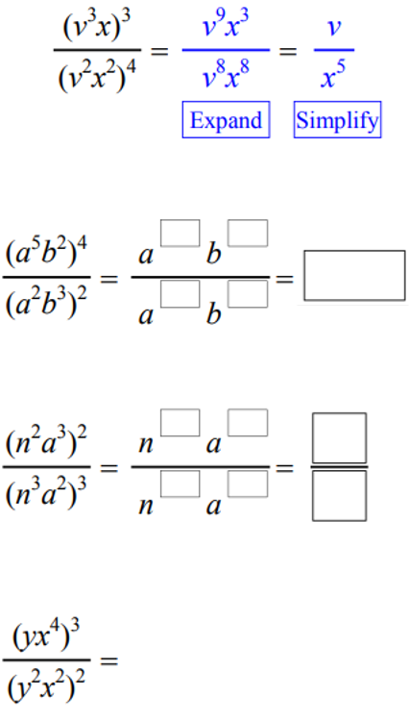 | $$a^{16}b^{2}$$ | $$\frac{1}{n^{5}}$$
$$\frac{x^{8}}{y}$$ | 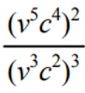  $$\frac{v}{c^{2}}$$

- Simplify the following expressions.
- $\frac{{\left(-2x^{2}\right)}^{3}}{-4x}$  $$2x^{5}$$ | - $\frac{{\left(3xy^{3}\right)}^{3}}{3x^{2}y^{4}}$  $$9xy^{5}$$
- $\frac{{\left(-ab\right)}^{3}×{\left(-ab^{2}\right)}^{2}}{-a^{5}b^{3}}$  $$b^{4}$$ | - $\frac{{\left(-2a^{3}b^{2}\right)}^{2}×16a^{7}b}{{\left(2a^{2}b\right)}^{5}}$  $$2a^{3}$$
- $\frac{4m^{2}n×3{\left(m^{2}n\right)}^{3} }{6m^{2}n}$  $$2m^{6}n^{3}$$ | - $\frac{{\left(7y^{2}z\right)}^{2}×3yz^{2}}{7{\left(yz\right)}^{2}}$  $$21y^{3}z^{2}$$
- $\frac{2{\left(ab\right)}^{2}×{\left(2a^{2}b\right)}^{3}}{4ab^{2}×4a^{7}b^{3}}$  $$1$$ | - $\frac{w^{8}}{18}$ $÷$ ${\left(\frac{w}{6}\right)}^{2}$  $$2w^{6}$$

- Simplify the following expressions.
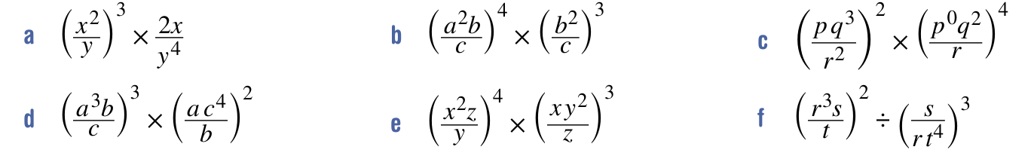  $$\frac{2x^{7}}{y^{7}}$$ | $$\frac{a^{8}b^{10}}{c^{7}}$$ | $$\frac{p^{2}q^{14}}{r^{8}}$$
$$a^{11}bc^{5}$$ | $$x^{11}y^{2}z$$ | $$\frac{r^{9}t^{10}}{s}$$

- Simplify the following expressions.
- $\frac{3a×3a×3a}{3a+3a+3a}$  $$3a^{2}$$ | - $\frac{3c×4c^{2}×5c^{3}}{3c+4c^{2}+5c^{3}}$  $$\frac{60c^{4}}{3+4c+5c^{2}}$$ | - $\frac{ab^{2}×2b^{2}c^{3}×3c^{3}a^{4}}{a^{3}b^{3}+2a^{3}b^{3}+3a^{3}b^{3}}$  $$a^{2}bc^{6}$$

